* **­­What is Docker & How to install it in Windows OS**

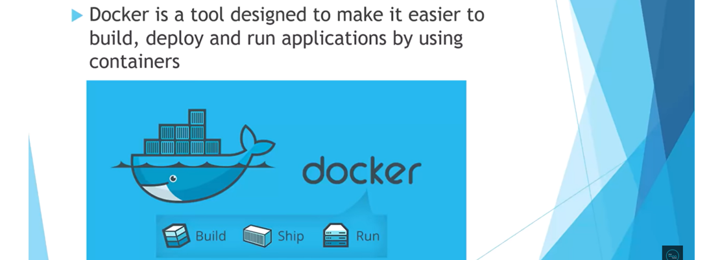



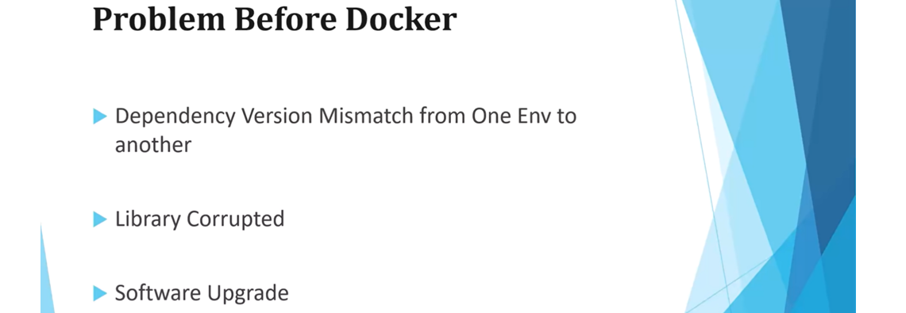

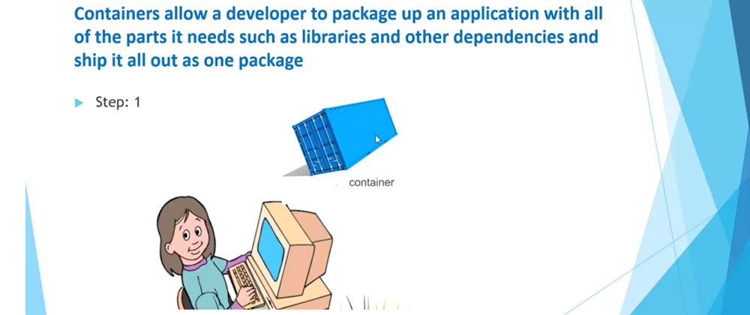





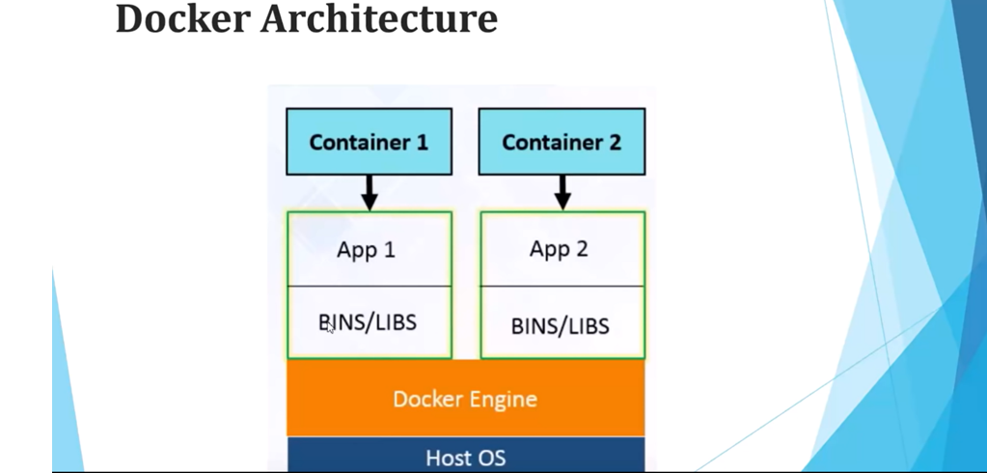

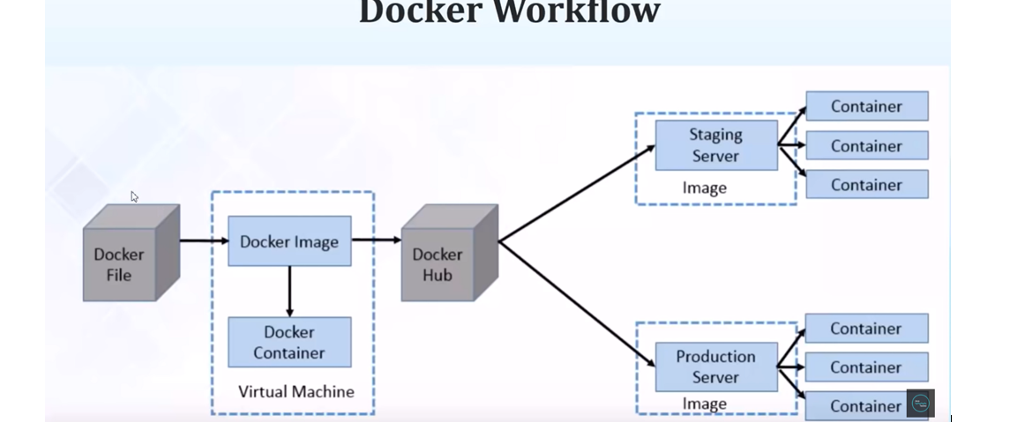

Docker hub is like a central repository of docker images.

* **Docker - Dockerizing your Spring Boot Application**

We can dockerize any java application so let’s create a spring boot application and then we will create a Dockerfile and then we will create a docker image and we will dockerizing our application means creating a docker file creating a docker image and run or deploy that image on docker container the entire process called dockerizing our application.

**Application**- **spring-boot-docker**

**Dependency** – **Spring Web**

Now let’s create one rest endpoint to verify whether our application is running over container or not.

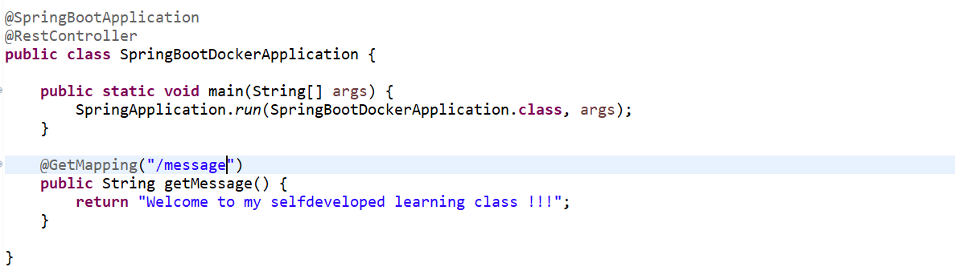

Let’s create one docker file

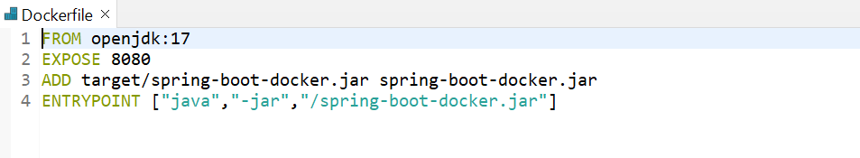

1st one is **FROM** means start with a base image containing with our java runtime, so here we are going to write a jdk related thing. This openjdk:17 image is available in our docker hub.

2nd one is **EXPOSE** I am giving 8080, so the mean of this expose make port 8080 available to outside this container.

3rd one is **ADD** so here we need to add our jar of this application (spring-boot-docker). So here let’s specify the path where we can get the jar **target/**spring-boot-docker.jar spring-boot-docker.jar

4th one is **ENTRYPOINT** so, here we need to specify the command to run the jar. ["java","-jar","/spring-boot-docker.jar"].

Till now we didn’t create the jar. So, now let’s create the jar first. So go to pom.xml file in <build> tag add one tag called <finalName> and specify jar name.

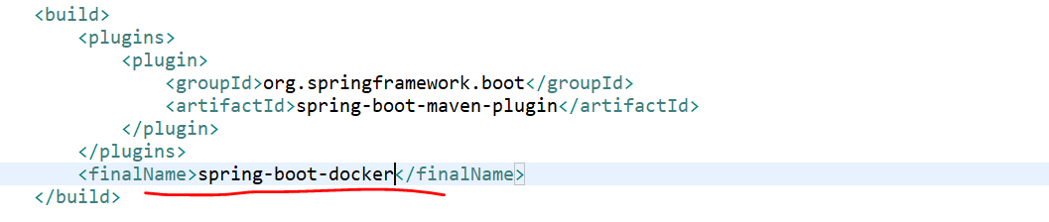

Now let’s generate our jar.

App->Run AS->Maven Install

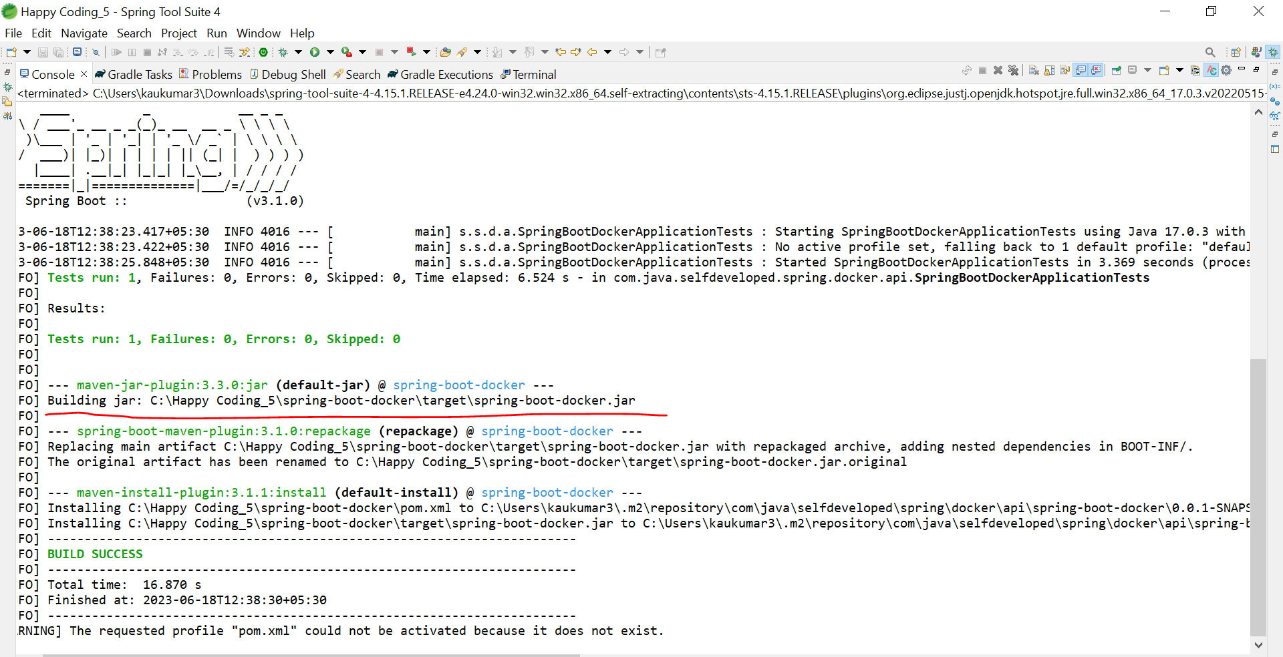

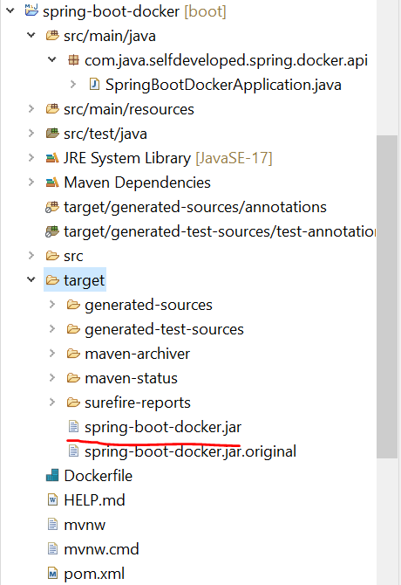

Now finally we have created the jar.

So now we need to create a docker image of it.

Go to project directory and open the command prompt, as we already installed the docker desktop so we can run all command through cmd as well. Type one command.

**++ docker build -t spring-boot-docker.jar .**

so as of now there is no images in our docker repository.

**++ docker logout**

**++ docker login**  //+dockerjimaihu +KrTum5h87@7

**++ docker build -t spring-boot-docker.jar .**

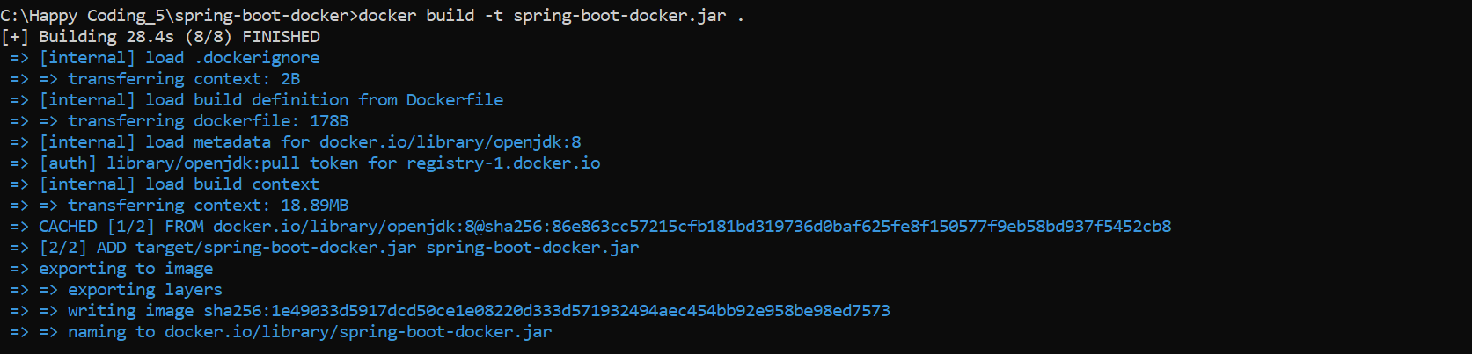

**++ docker images**



Now we need to run this docker images.

**++ docker run -p 9090:8080 spring-boot-docker.jar**

So, this 8080 is my local port what we specify in our docker file and this 9090 will be run on our container.

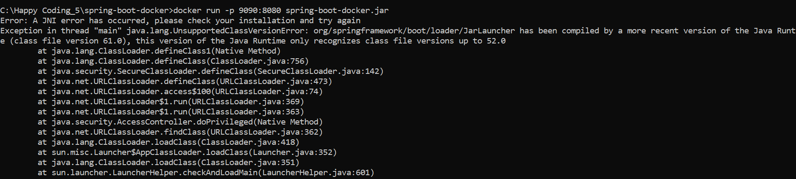

Getting exception so. Let’s fix this issue first.

Java build path-> Library->alternate JRE-> jdk 17 path

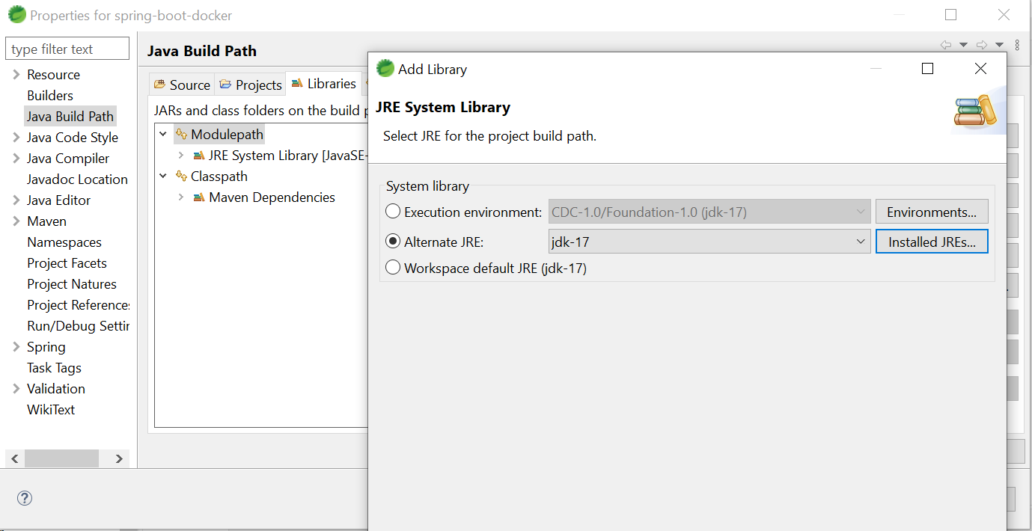

Java app->configuration->java compiler-> 1.8 selected( compiler version should be lower version of our jdk and jre earlier it was 17)

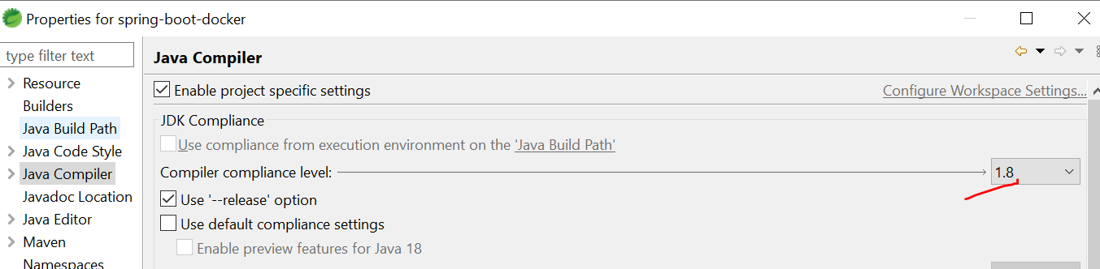

Now build the project again and create a docker image and then try to run it.

While do Maven clean our jar got remove

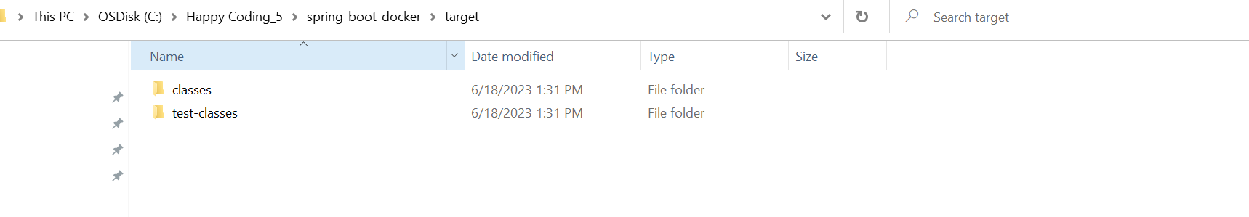

Now let’s create our jar using **Run AS** -> **maven install**

Now we created our jar again and now let’s create a docker image and let’s try to run it.

Ultimately, we found the issue the issue was we are running our application in local on jdk 17 and we specified the jdk version 8 on our Dockerfile.

So always keep in mind our java compiler version always should be lower than our jdk or jre version.

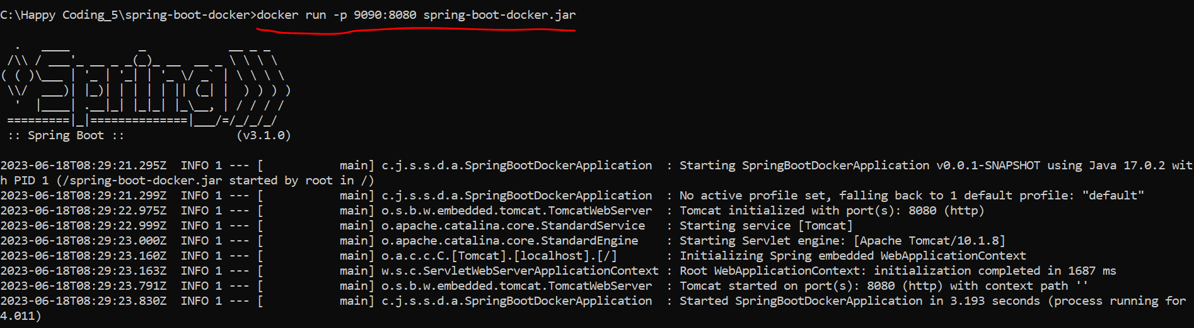

So, here 9090 is our container port and 8080 is our local port.

Now our application is deployed and running on docker container you can access on port 9090. Now once our docker image is deployed in our container you can be able to access it.

Now instead of our local host let’s use our System IP address.

<http://192.168.65.0:9090/message>

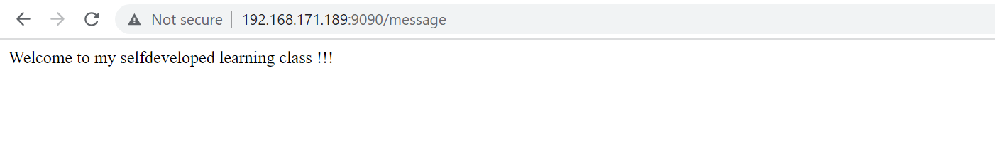

Similarly, we are exposing our local port 8080 as well so we can access on local host:8080 as well.

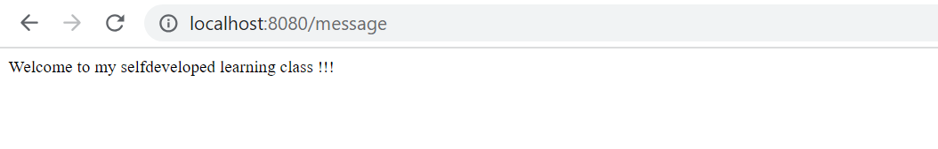

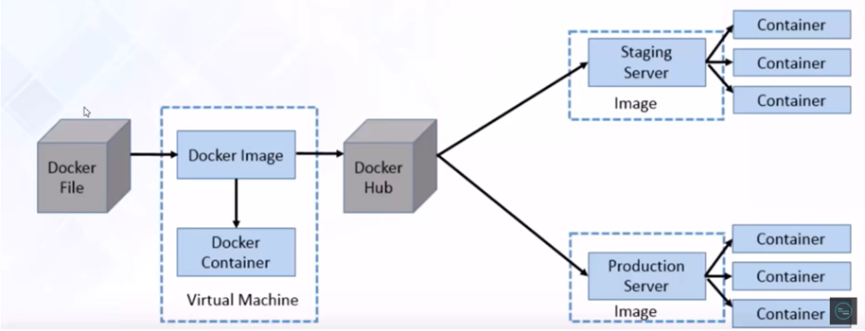

So, this is what our docker flow we have created the docker image and we up our instances in our docker container and we are able to access it our port 9090.

* **Docker - Pushing and Pulling Docker Image to Docker Hub**

Let’s see how to push our docker image to docker hub and how to pull it from docker hub.

What exactly this **docker hub**. Docker hub is a kind of repository. as we have a repository like Github where we can store our SourceCode similarly docker image we can store in our **docker hub**.

As this docker hub is a kind of repository so we need to create an account in our docker hub.

**Credentials**: dockerjimaihu/KrTum5h87@7

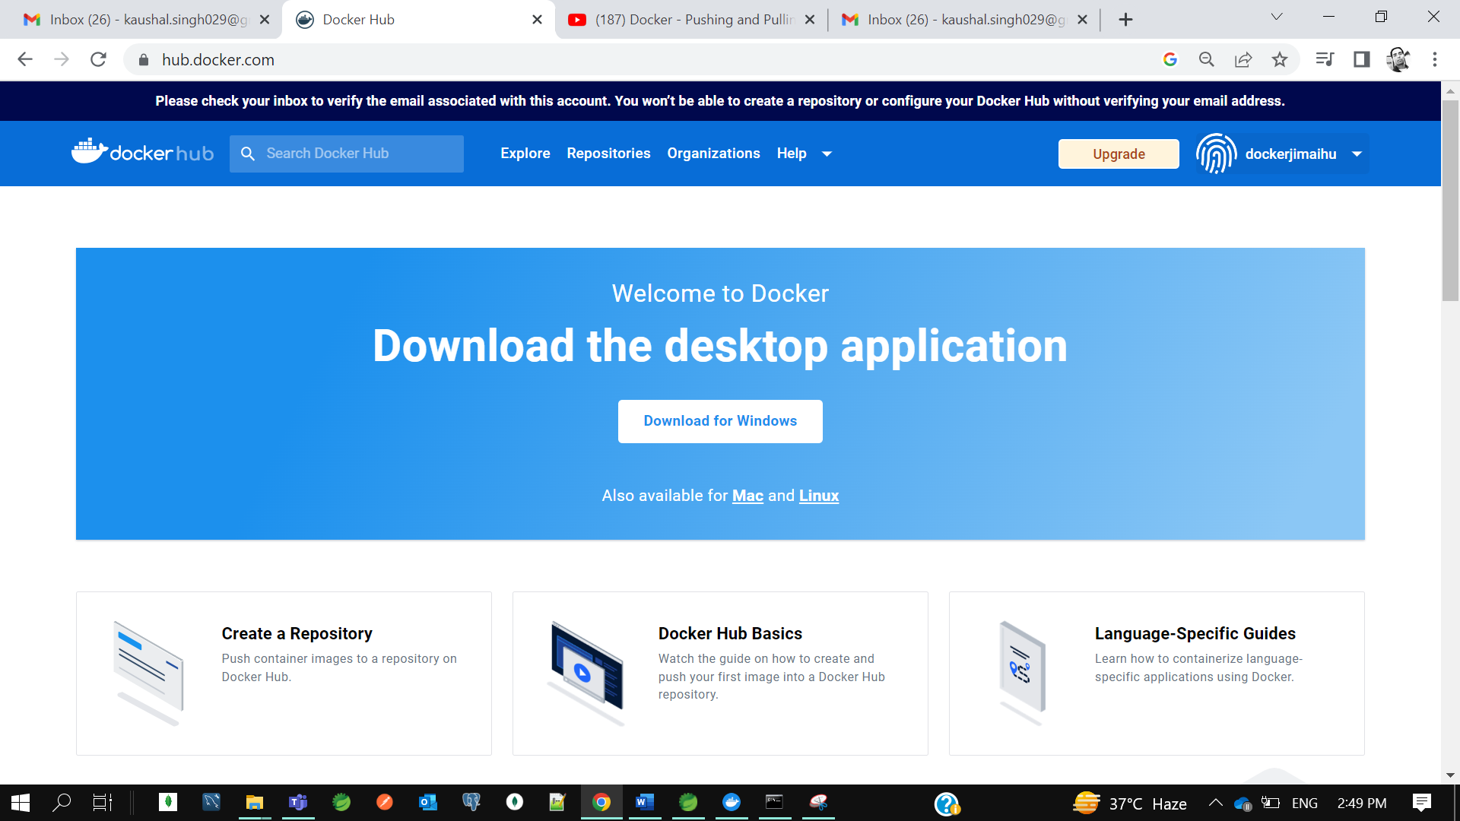

So, we logged in.

Now we need to login from the cmd.

**++ docker login**

**++ docker image ls**



So, we have created one docker image in previous tutorial so let’s push to our docker hub.

As docker hub is a public repository. so, we need to specify some tag to our docker image to identify that this docker image belongs to this **dockerjimaihu**. So, we need to specify a tag. Our tag should be same as our docker userid.

So, to specify a tag there is a command in docker

**++ docker tag spring-boot-docker.jar dockerjimaihu/spring-boot-docker.jar**

To push our docker image on docker hub

**++ docker push dockerjimaihu/spring-boot-docker.jar**

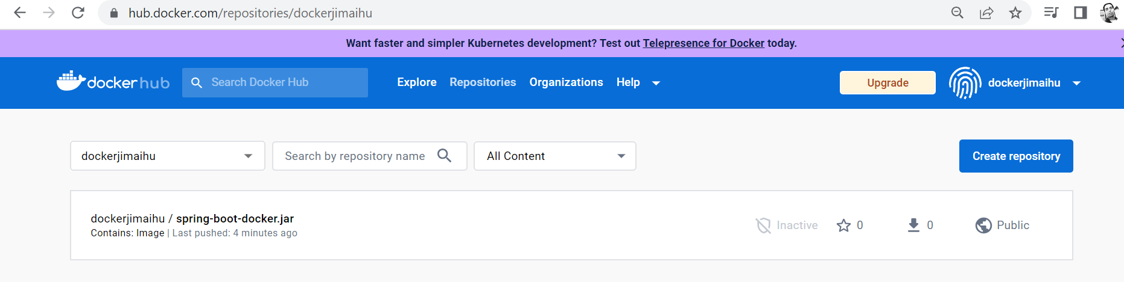

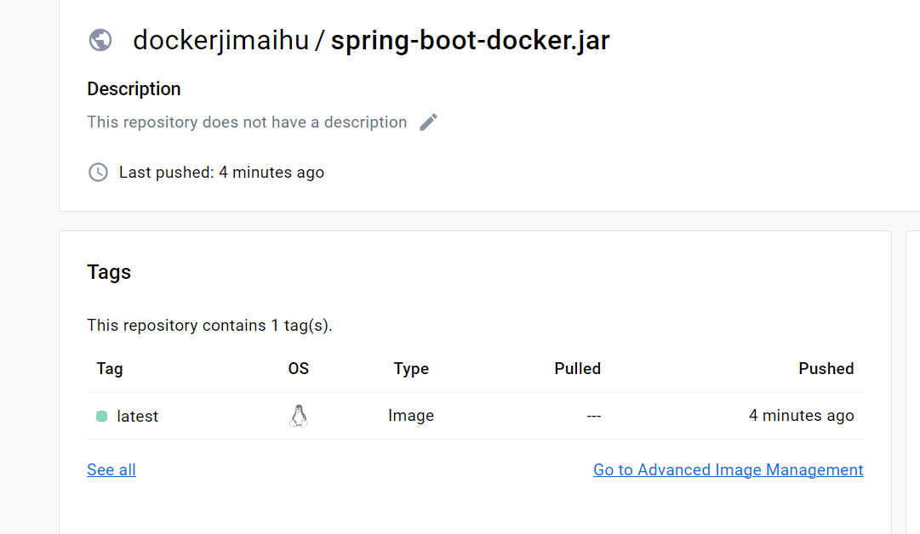

So, we can go to our docker hub repository, and we can see our **spring-boot-docker** image.

Now let’s pull this image and run the docker image

**++ docker pull dockerjimaihu/spring-boot-docker.jar:latest**



Now we pulled the image. Now let’s run…

**++ docker run -p 9090:8080 dockerjimaihu/spring-boot-docker.jar**

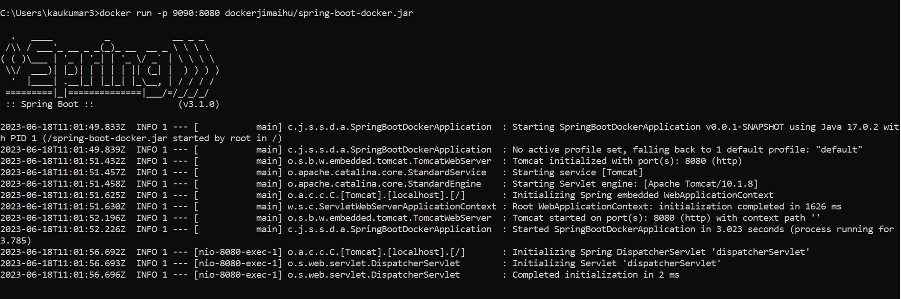

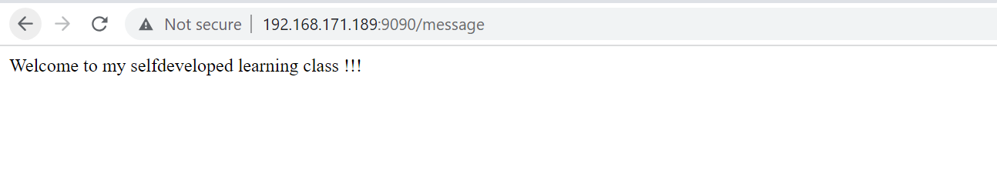

So instead of our localhost we need to use our Ip Address.  
so this is so easy developers no need to install anything in their local machine, they just need to pull the image from docker hub, and they need to run it on their local system.

* **Build and push Spring Boot Docker images using Maven plugin**

So earlier we were using docker file to create a docker image now let’s use maven plugin.

Now let’s create a springboot project and we will dockerize using maven plugin.

**App**- spring-boot-docker-maven

**Dependency**-Spring Web

Now go to pom.xml and let’s change the jar name here

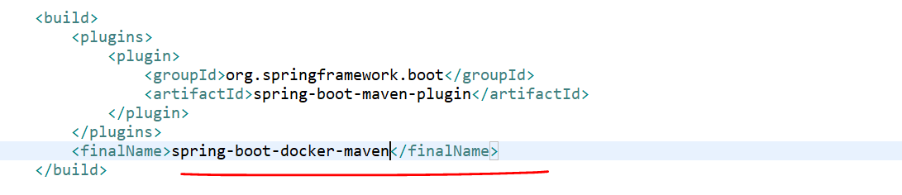

Now let’s create the Dockerfile.

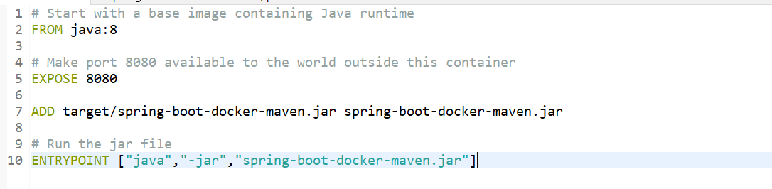

Now we need to generate the jar.

Run AS -> **Maven Install**

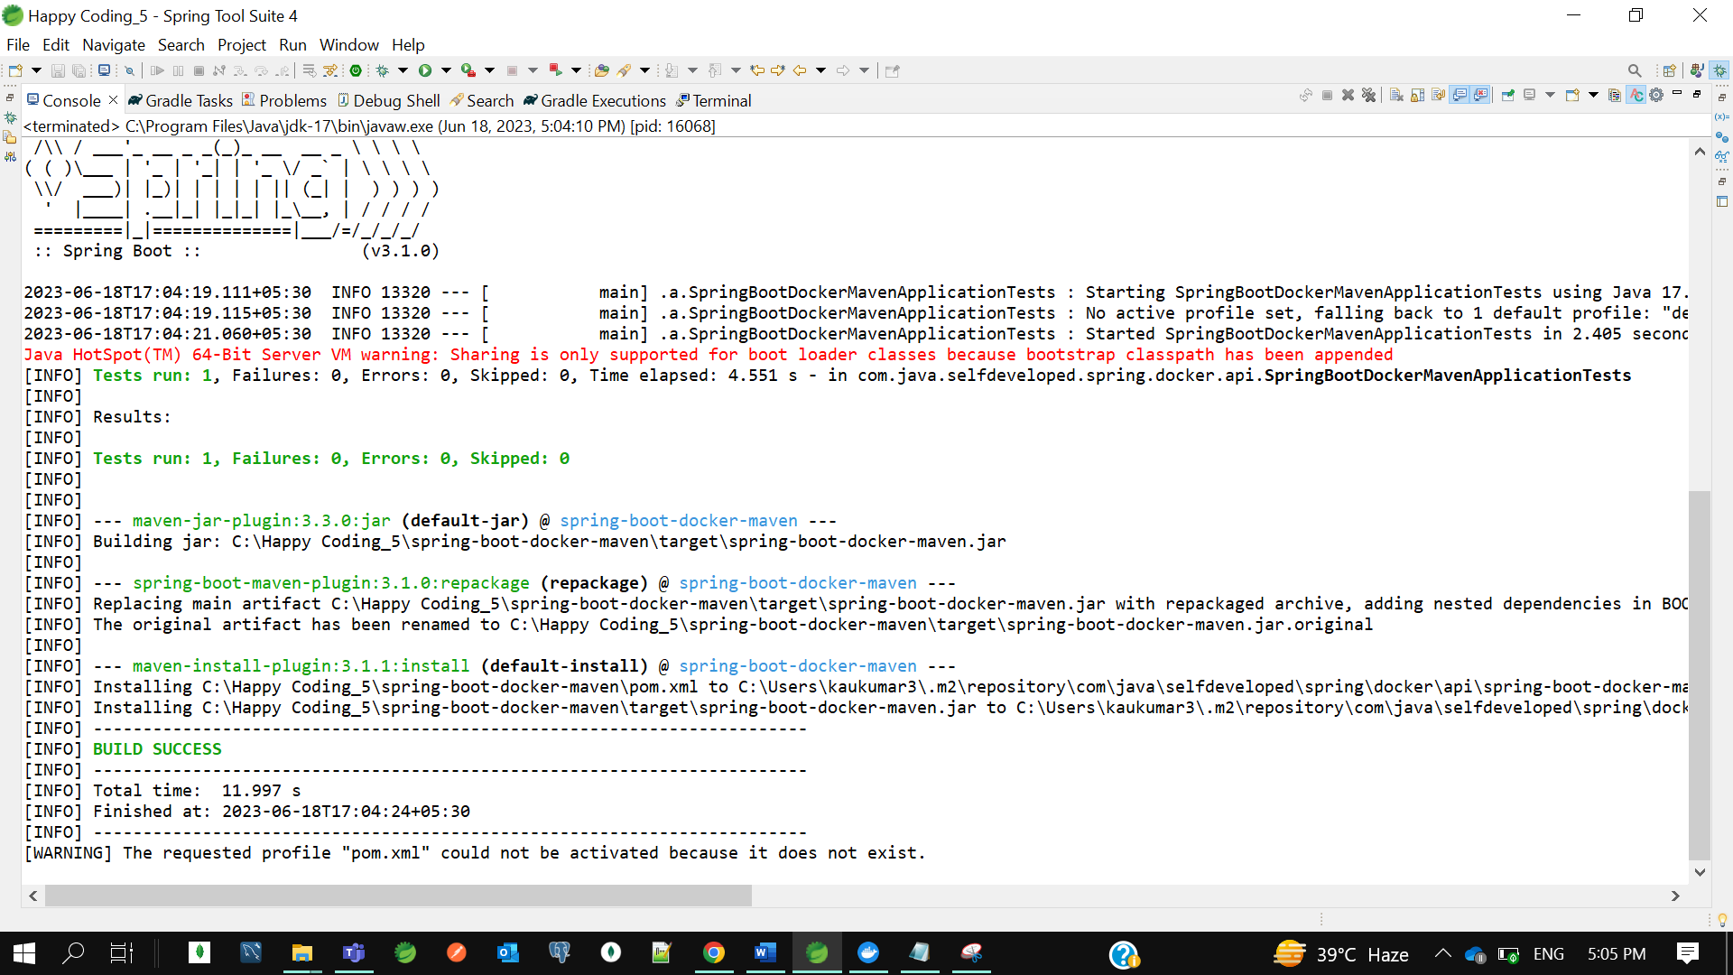

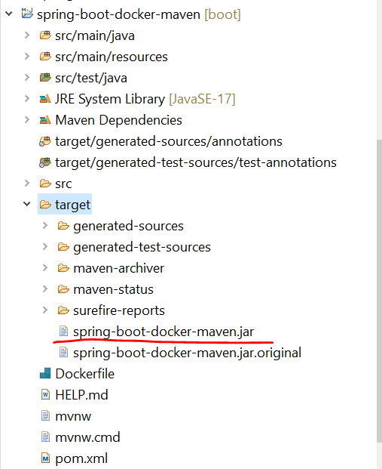

>>> Now let’s add the maven plugin to build an image and push it to the docker hub.

so inside plugins let me add the plugin.

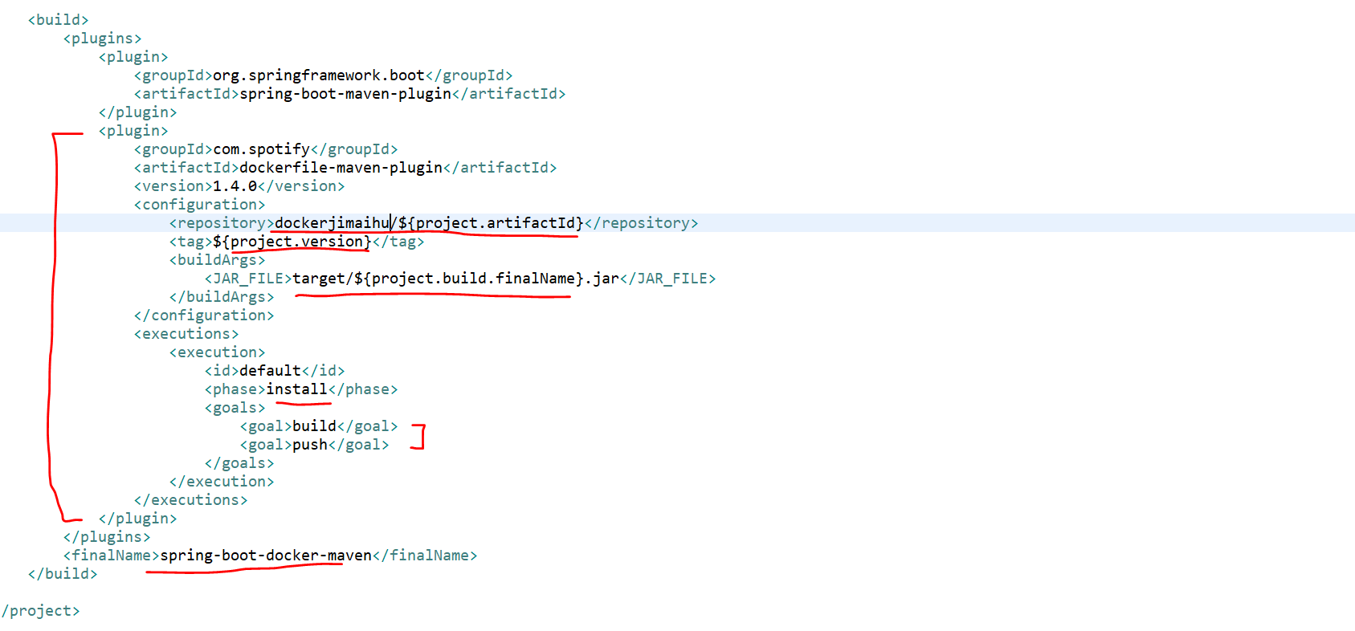

So, the plugin is **dockerfile-maven-plugin**. The version is 1.4.0. in the repository we need to specify the docker_id here. docker_id is nothing the username of your docker hub. So here the docker_id is **dockerjimaihu** andthen the project artifact id which is **spring-boot-docker-maven** so, with the same name the image will be deployed to the docker hub. We specified the jar file here target/**project.build.finalN**ame which is **spring-boot-docker-maven.jar.** we set the goal as build and push inside the install.

So, once you run the docker install it will cover both build and push.so, it will build the image and it will push to the docker hub.

Before docker install let’s first login to the docker hub through cmd.

*** I got some exception here*********

* **Building Docker Images using Jenkins step by step | Devops Integration**

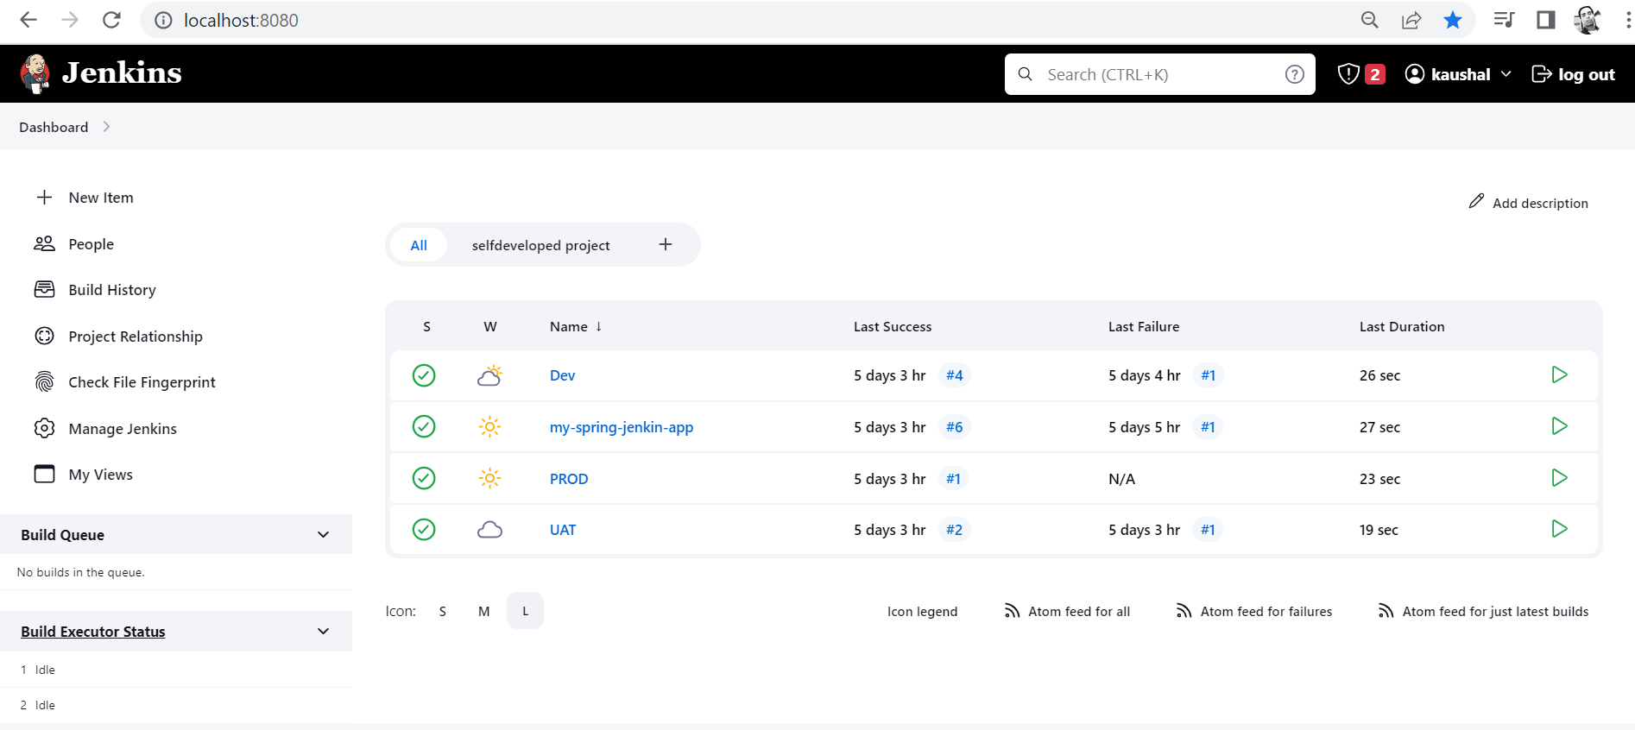

Let’s start with Devops Integration. So, you should have basic knowledge about docker and jenkins.

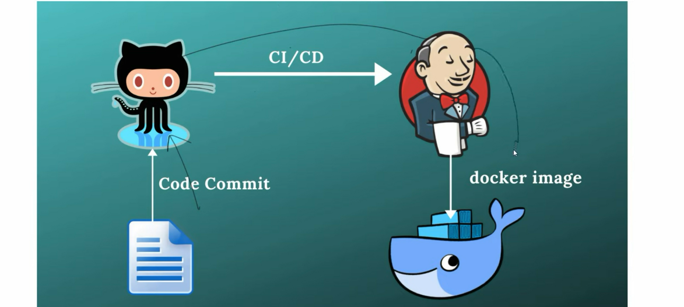

We will create one github repository. and that repo we will integrate with jenkins. So that each code commit to my github jenkins will process continuous Integration and deployment. Once the Jenkin build is succeeded, then jenkins will create a docker image for us and he will push the docker image to docker hub.

So, here we are not going to create a docker image manually and we are not going to push the docker image to docker hub. All the dockerizing stuff would be done by jenkins itself.

Let’s create a java project and that java project will sink with github and then github will link with Jenkin.

**App**- docker-jenkin-integration

Now we specify the jar name in our pom.xml

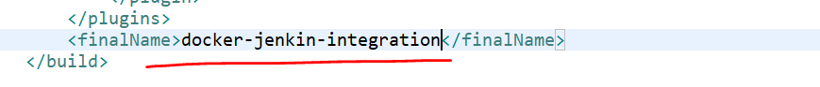

**Github:**

Create a github repository with name **docker-jenkin-integration** and commit our code to github.

We have committed and pushed our changes to github using below cmd-

Gilt Repo- <https://github.com/kaushal8707/docker-jenkin-integration.git>

* git init
* git status
* git add .
* git commit -m "first commit"
* git branch -M main
* git remote add origin https://github.com/kaushal8707/docker-jenkin-integration.git
* git push -u origin main

we have committed our code to main branch.

So, we have created code base and we sink with github.

Now this github need to sink with jenkins.

Now run the jenkins war our start jenkin which will run on port 8080

Now create a job and select free style project. And follow jenkins initial tutorial.

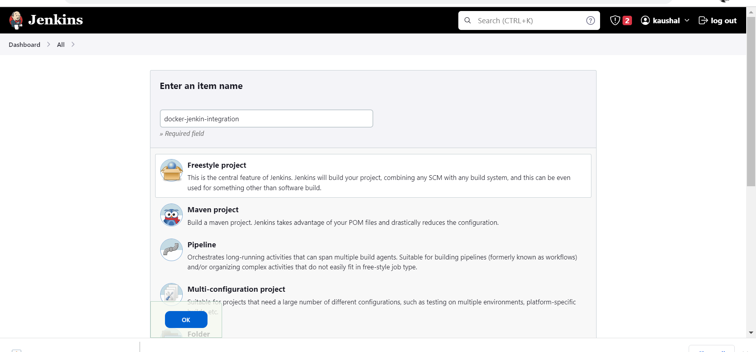

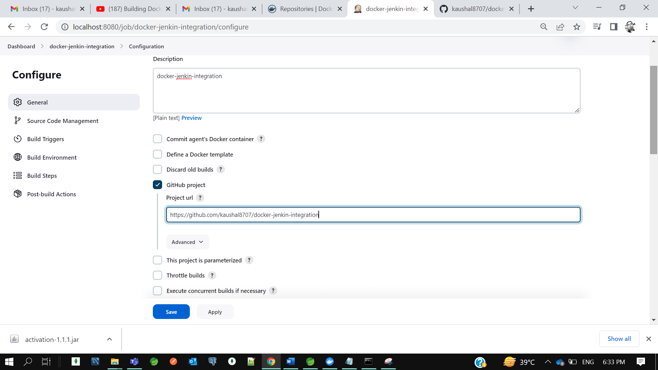

**Jenkin credential- kaushal8707/KrTum5h87@7**

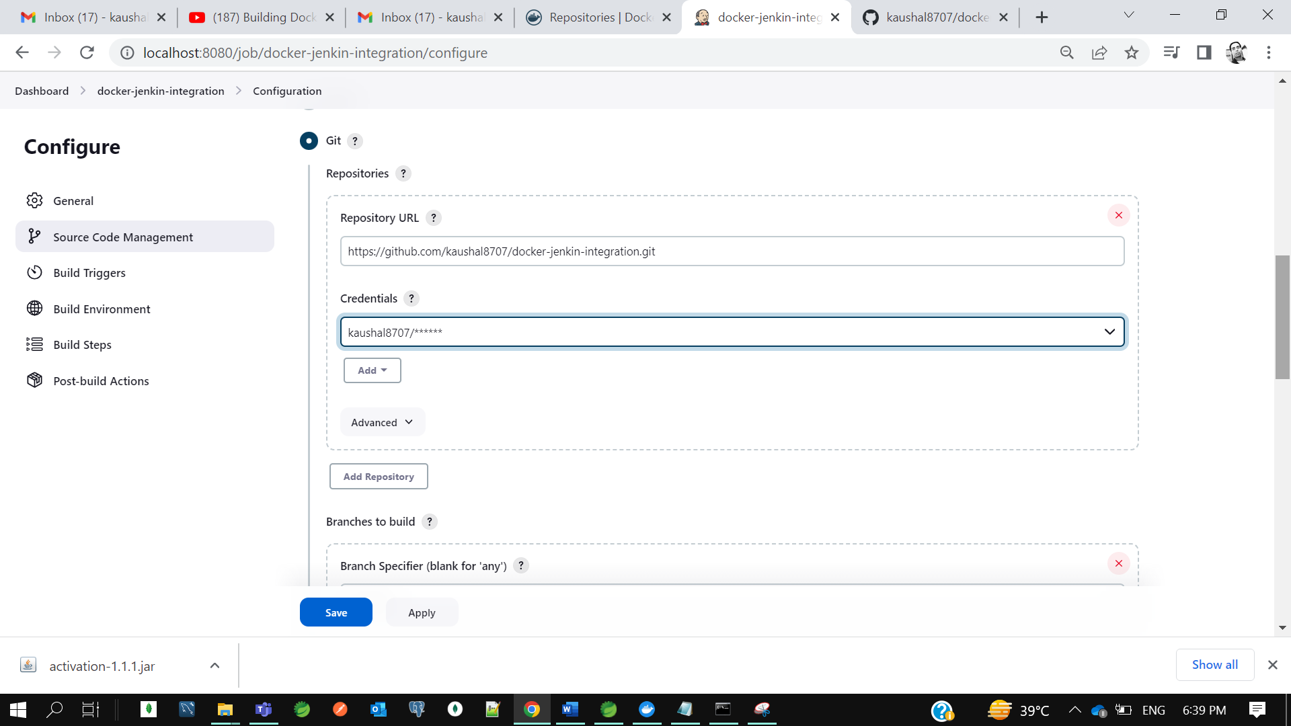

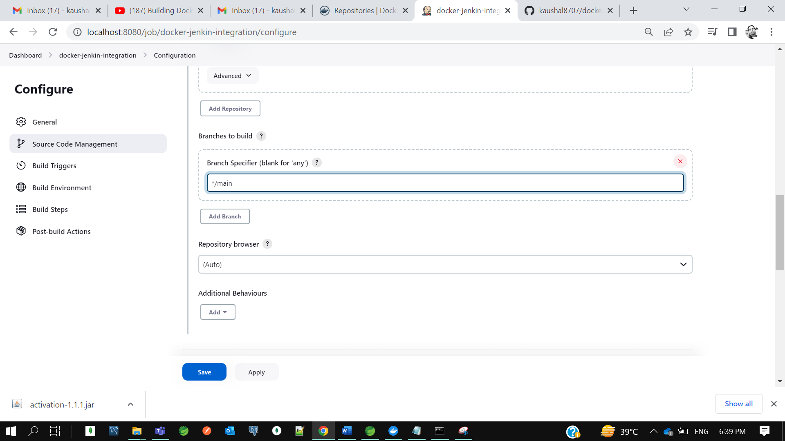

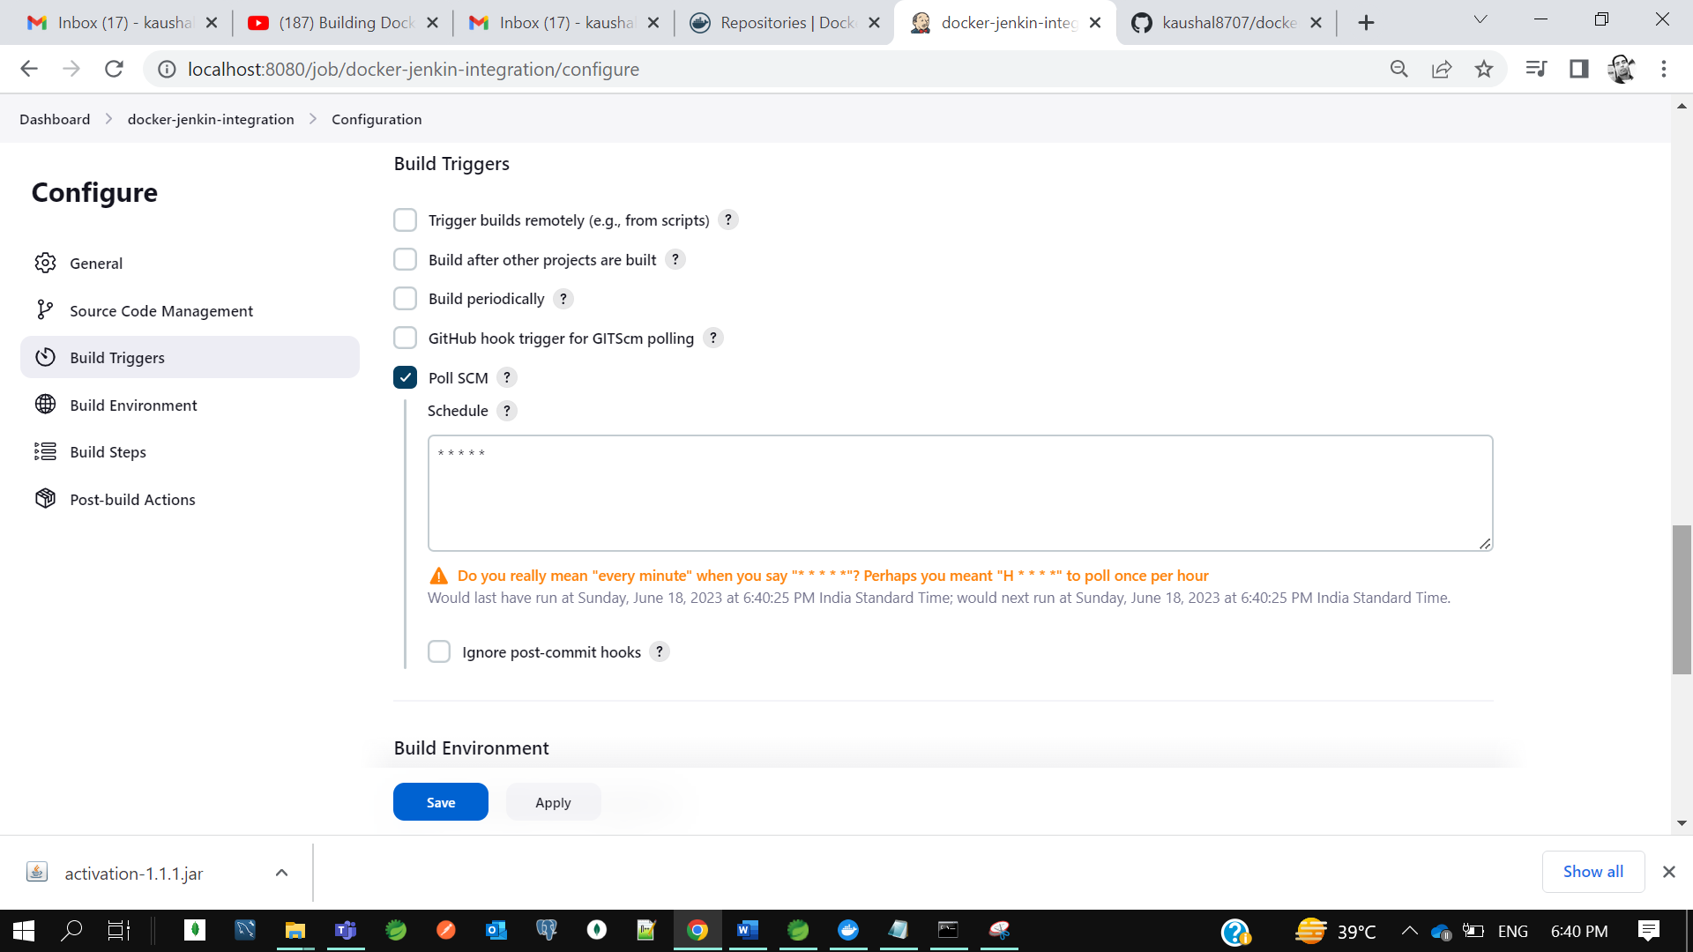

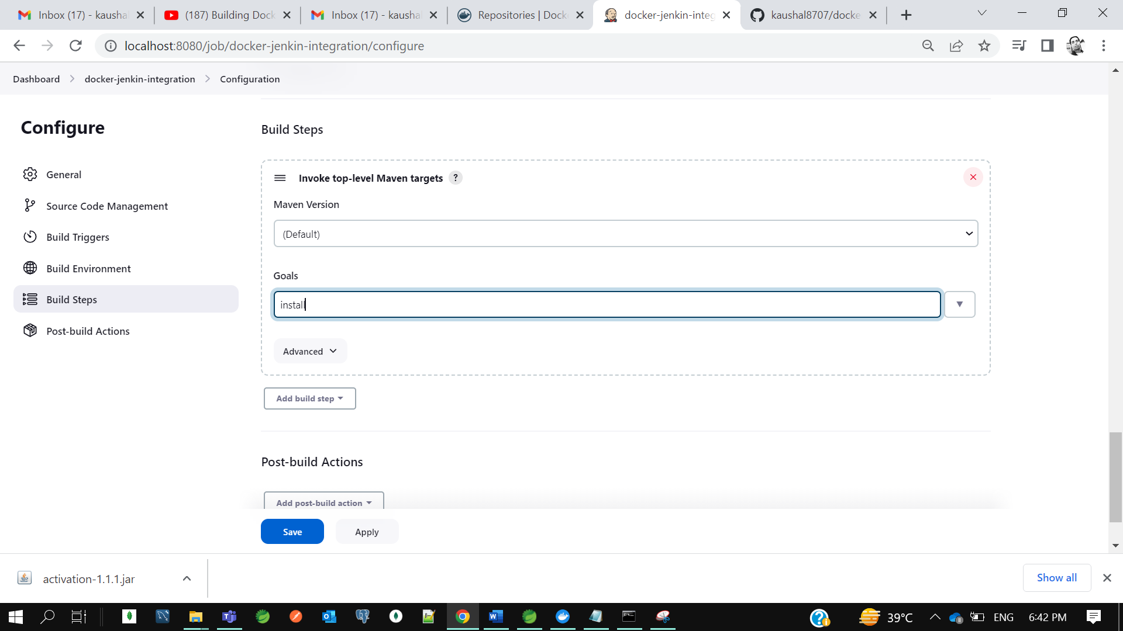

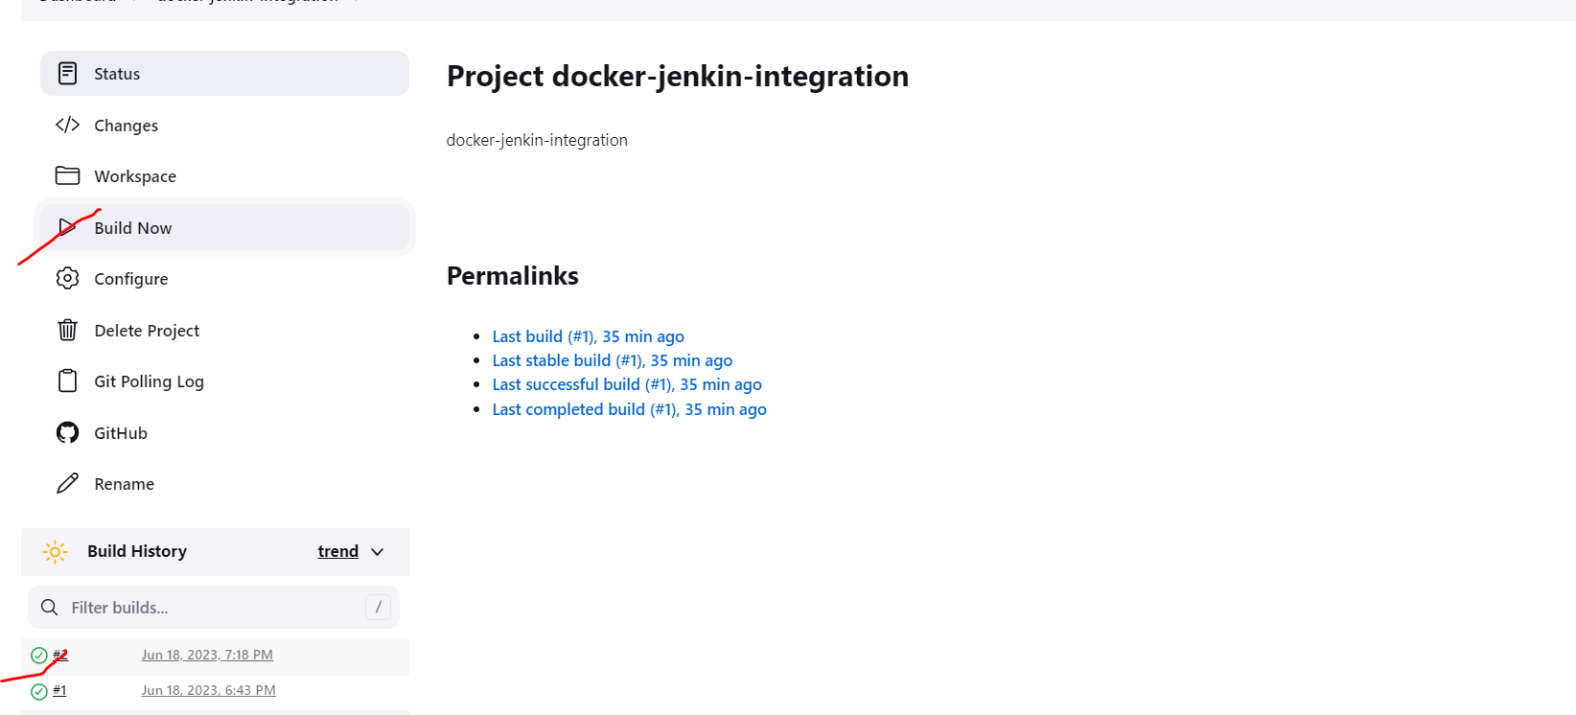

Our build got successful.

Now let’s verify the sink between github and jenkins we will change the code and commit in github the build should automatically start in jenkins. So, when we will commit jenkins will start the maven goal install which we configure to start the maven build.

So, we can see our build got succeeded.

Now we need to integrate jenkins with docker

So, go to jenkin we need to add one plugin. As I already installed docker plugin

Jenkin Home-> Manage jenkins->plugin-> installed plugin-> 3 docker plugin as marked

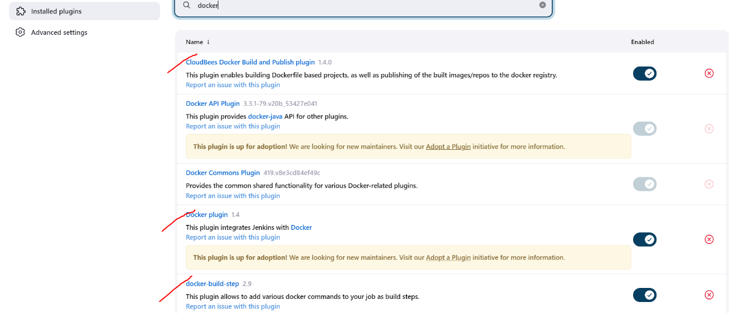

To verify either your jenkins plugin installed successful or not.

Go to jenkins-> project->configure-> add build steps.

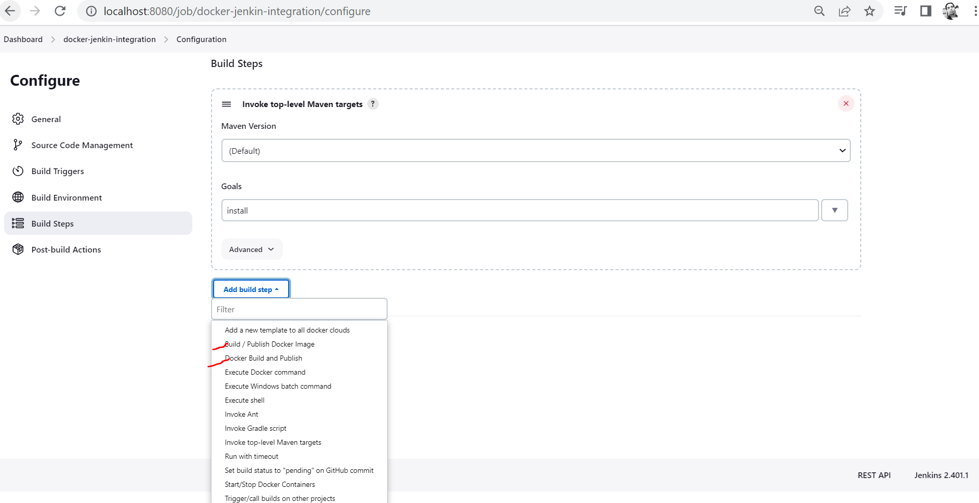

***Now how jenkins will understand your java code that we need to create a docker image.

***How we can instruct jenkin that take this code and build a docker image for us.so for that we need to create the Dockerfile in our code. In our java code we will add Dockerfile and that we will push to github. Now jenkin will load it from github and he will process the build once the build is succeeded jenkin will able to create the docker image and he will be able to push the docker image to docker hub.

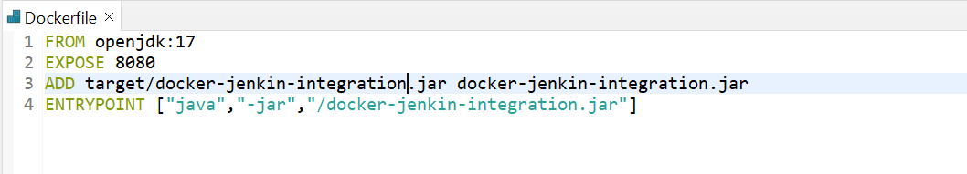

Let’s commit this code to git.

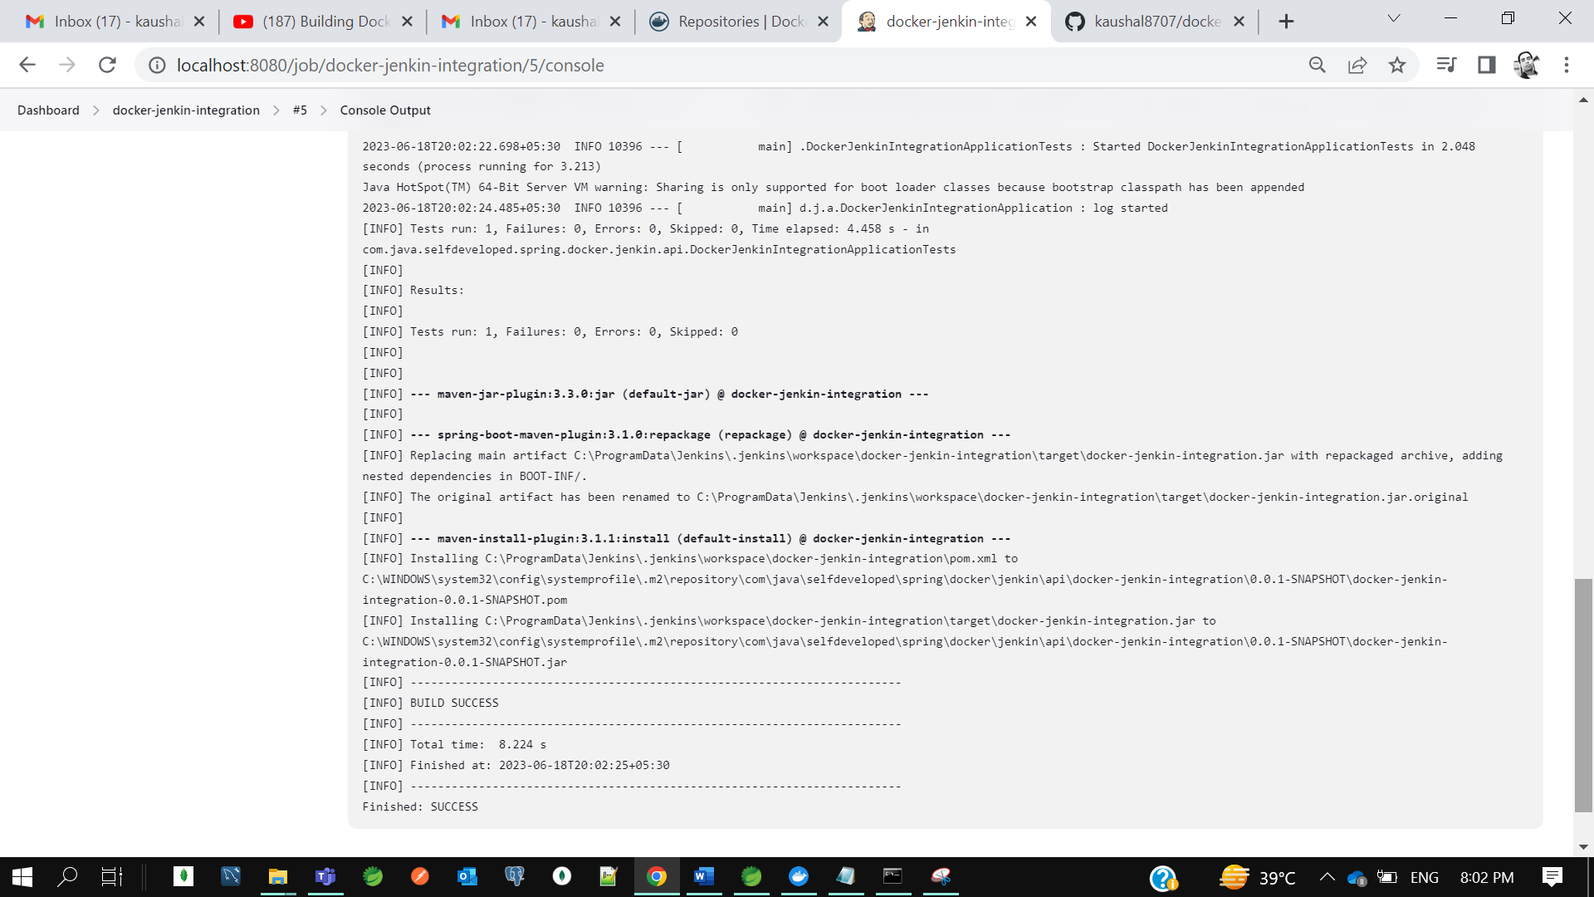

So, build got successful.



So, in jenkin we added the plugin and in our code we already added the docker file.

How we can instruct jenkin that take this code and build a docker image for us.so for that we need to create the Dockerfile in our code. In our java code we will add Dockerfile and that we will push to github. Now jenkin will load it from github and he will process the build once the build is succeeded jenkin will be able to create the docker image and he will be able to push the docker image to docker hub.

So for that I need to give Docker Hub credential to Jenkins.

Project jenkin-> configure->add build step->docker build and publish->

In repo name of docker hub give **tag_name/docker_image_name**

And along with it we need to add our docker hub credential

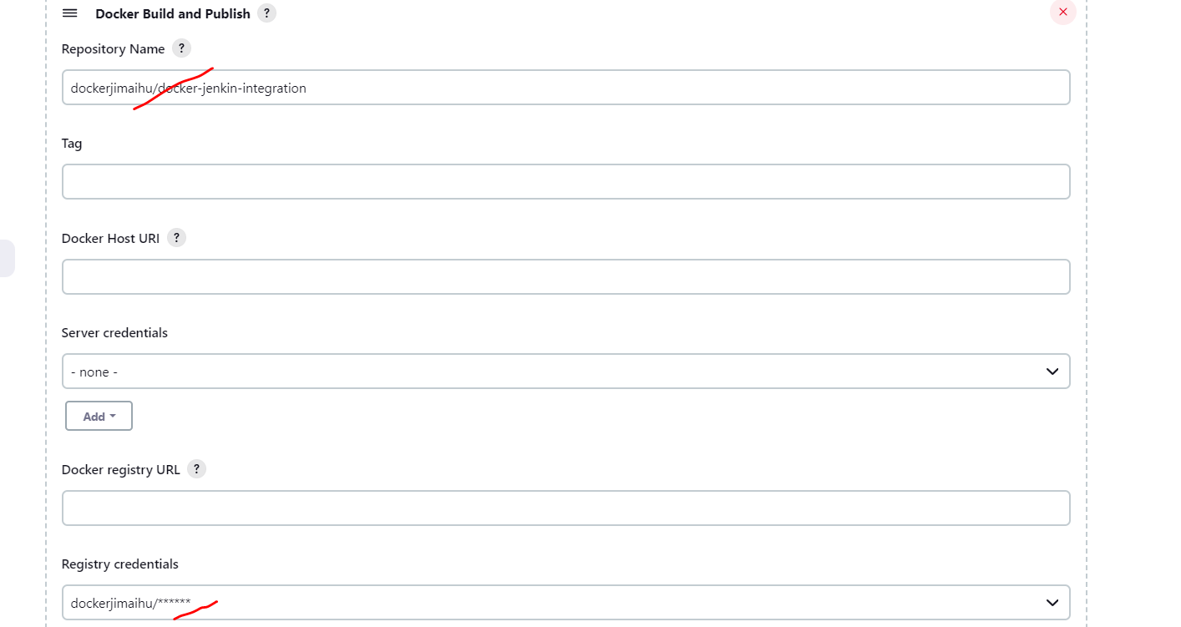

Credential – dockerjimaihu/KrTum5h87@7

Now start the build so it will create a docker image and push that image to docker hub.

* **Build & Push Docker Image using Jenkins Pipeline | Devops Integration Live Example Step By Step**

Here we will learn how to build and push docker image to docker hub using **Jenkins Pipeline**.

**Integration workflow-**

As a developer we commit the code to the github which act as a version control tool. Now we need to perform **continuous integration and continuous deployment** so, for that we need to integrate github with our jenkins. When I say continuous integration and continuous deployment it means with my committed code, I want to build my project then I want to create docker image of my application then I want to push my docker image to my docker hub.

Now the question is how will jenkins know what steps you want to perform. Whether first you want to build your project then you want to create a docker image then you want to push docker image to docker hub how jenkins will know these steps as part of continuous integration and continuous deployment. So, that’s why the **Jenkins Declarative Pipeline** concept came into picture. Where you need to define all the steps what you want to perform in a file called jenkins file.

So now when going forward when you commit your code to github jenkins will read this **jenkins file** from your project and he will perform the request steps you mentioned.

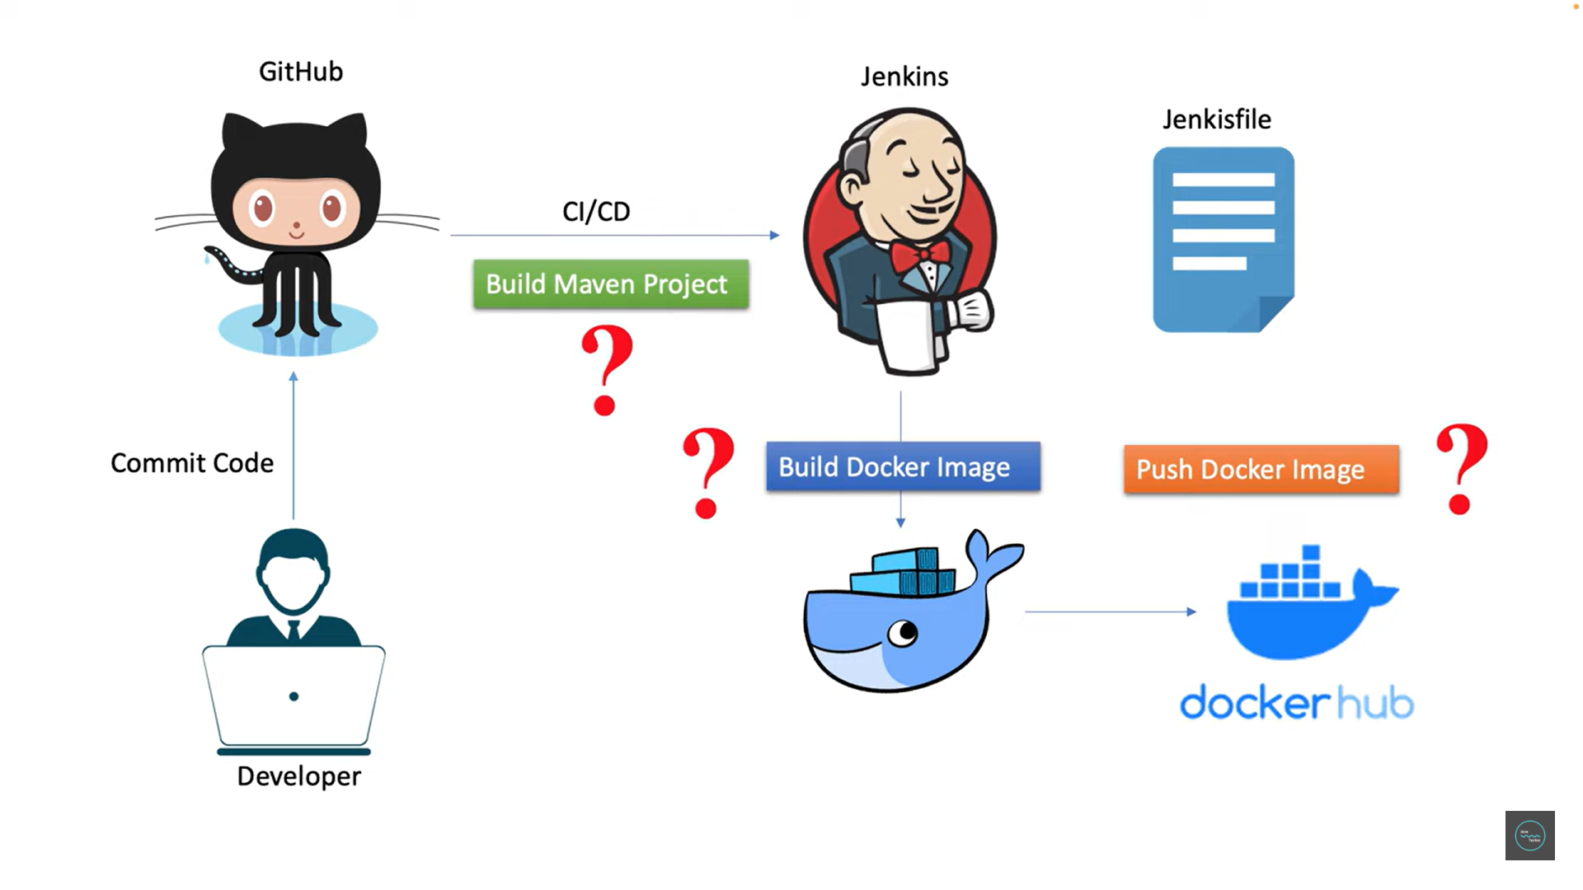

**Application**- **devops-integration**

**Git repo**- <https://github.com/kaushal8707/devops-automation>

Now we have committed our code to github, so my machine code is **sync up** with the github.

Now I need to integrate the jenkins with github so that I can perform CICD steps.

Let’s create a pipeline or a new job.

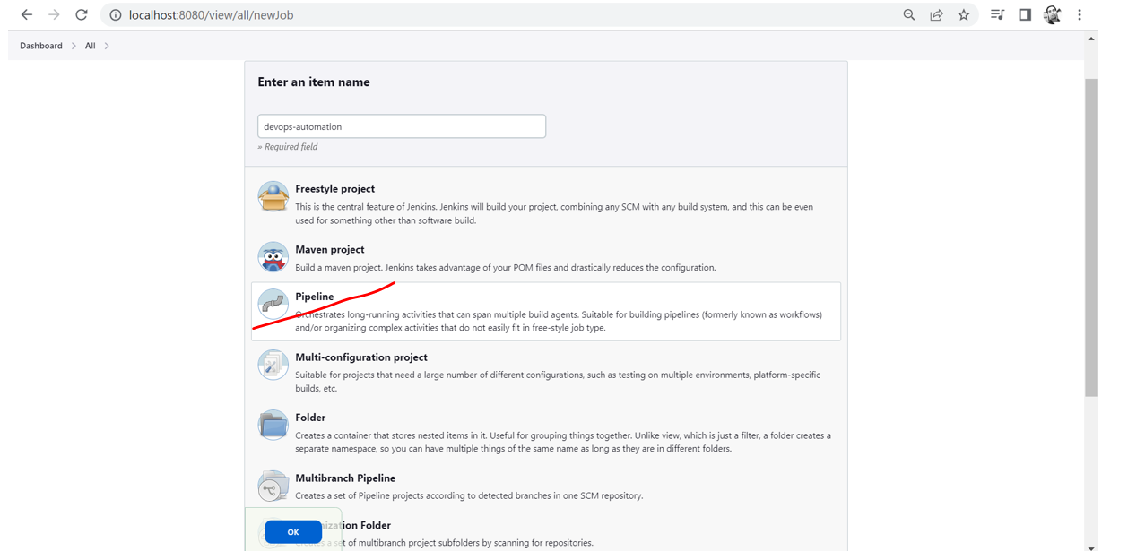

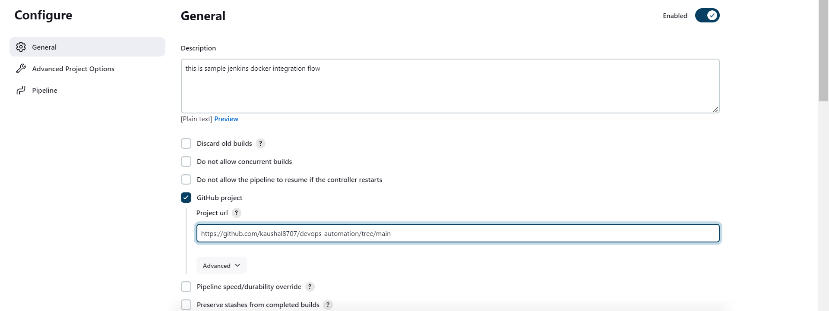

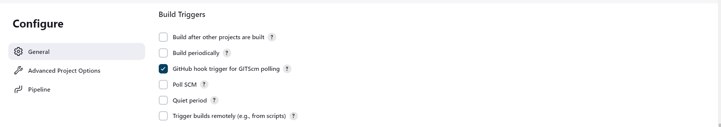

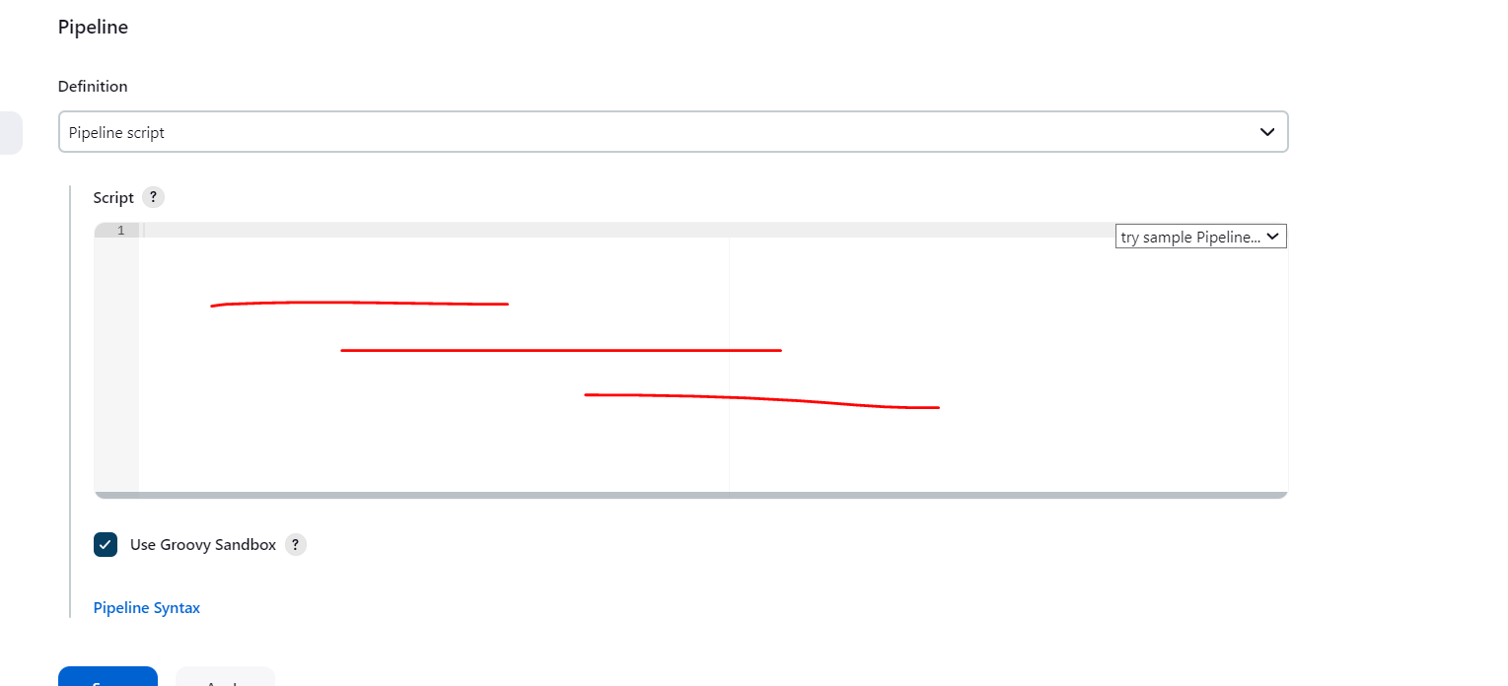

Here u need to tell to jenkins what steps u need to perform. 1. u need to define build maven project. 2. Build docker image and 3. then push docker image to docker hub.

These 3 steps we need to define in the jenkins file.

So, there is 2 options either u can directly write jenkins file here if not if u have jenkins file in ur github project then directly u can import it from there, let’s see both.

As per CICD I need to tell to jenkins first build my project, check out my code from github then build my project. That’s what I need to define in jenkins file.

To add or show whare need to add maven path or version go Manage jenkin->tool->maven(optional)

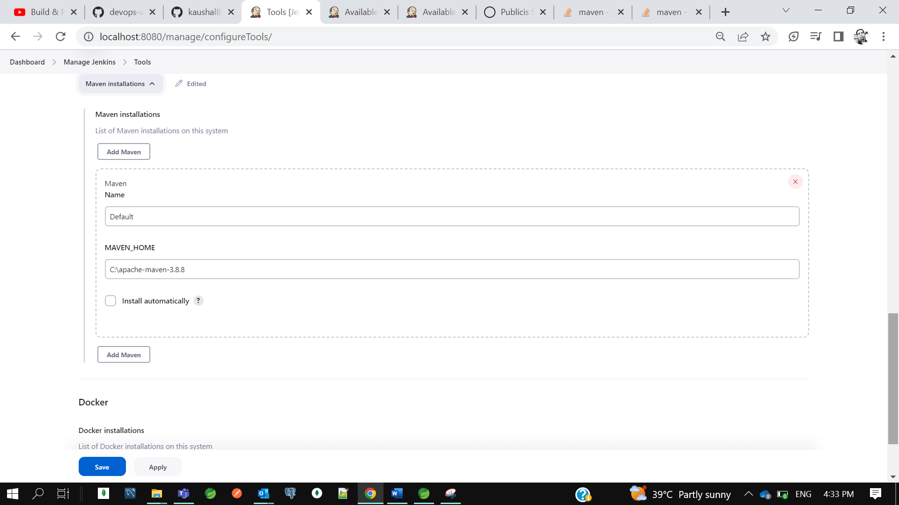

First, I will tell to my jenkins this is my pipeline. Then as part of my pipeline use agent as any then I will specify the tool which I use to build my project which is nothing maven. you can define the maven which you have in your jenkins. So, I am telling jenkin pipeline please use the maven tool to perform build operation.

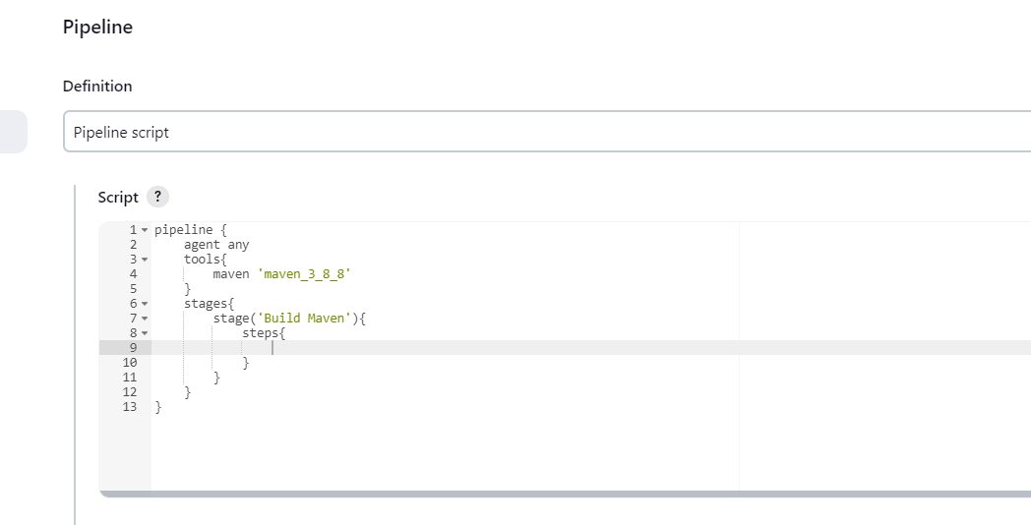

Now next I need to define the stages. Stages is nothing the steps u want to perform. Build maven project is one stage build docker image is another stage then push it to docker hub is another stage. This is how we can define multiple stages.in this stage I just want to define the steps. I just want to tell to the jenkins as part of this pipelines I want to perform multiple stages or stage inside that I want to perform multiple steps. So, I want to tell to jenkin that I want to perform one stage Build Maven and inside that stage I want to perform is I want to checkout code from github and then we need to perform maven clean install.

So, to get the syntax to checkout code from github. You can directly use the pipeline syntax. Since it this is public no need to give credentials.

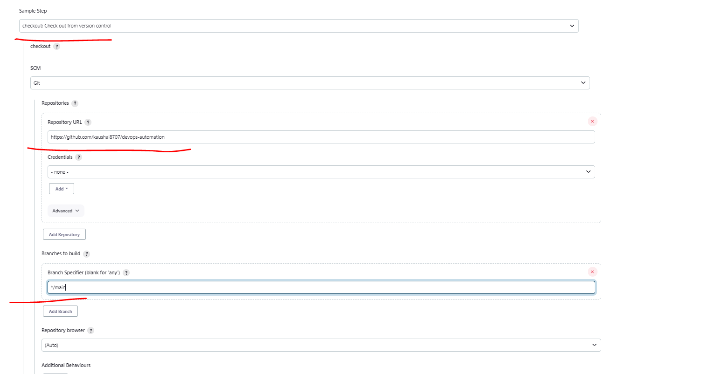

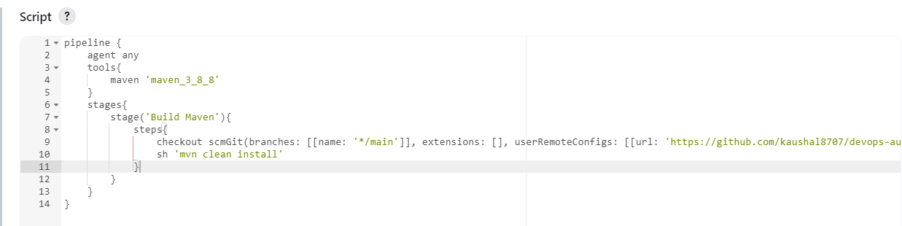

So, as per the steps I am telling this do the checkout and just execute mvn clean install its nothing the packing.

Let’s save it and build now.

Earlier we were getting exception 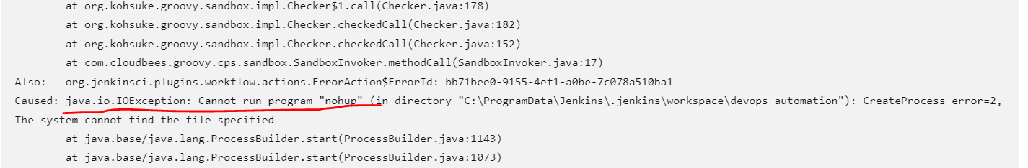

The error is like c

[Jenkins pipeline sh fail with "cannot run program nohup" on windows](https://stackoverflow.com/questions/45140614/jenkins-pipeline-sh-fail-with-cannot-run-program-nohup-on-windows)

We have fixed this issue after setting get path in env var.

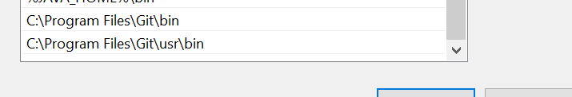

Bcz we are running cmd **sh ’mvn clean build’** and this is a linux cmd

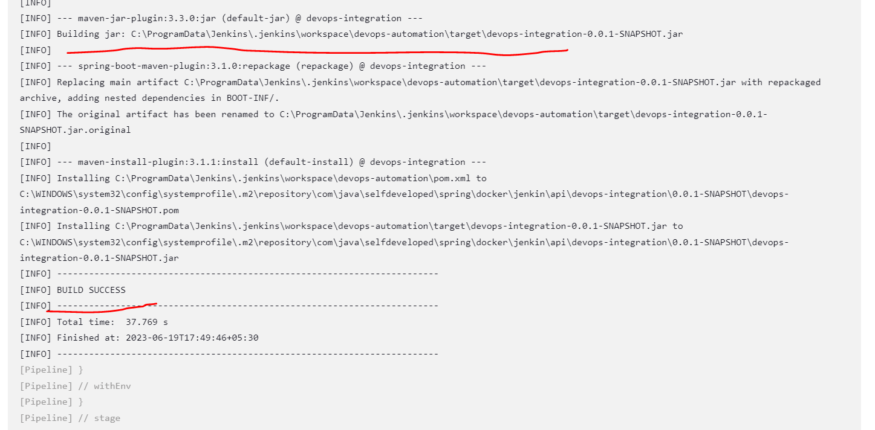

Now our build got success…

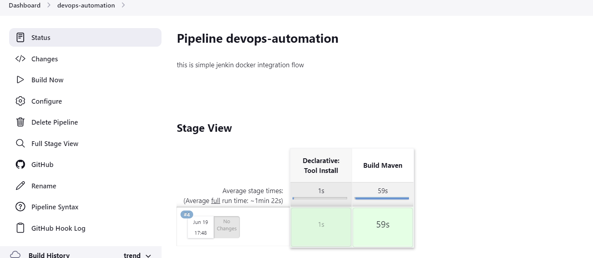

*** So we had performed the first step that we just tell to the jenkins using jenkins file build my maven project. Now next we need to tell to the jenkins that build docker image.

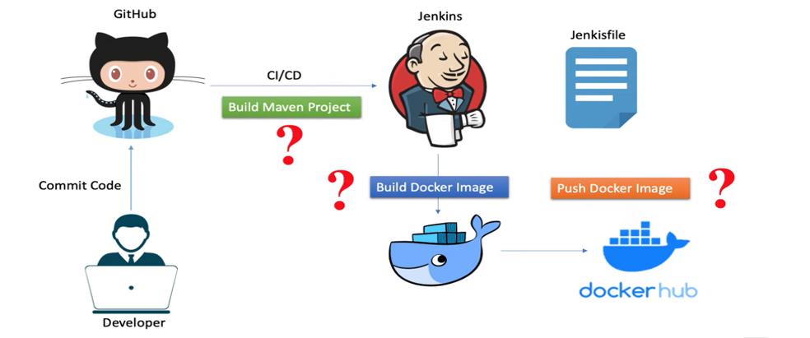

So, first step we have done now we will go with the second step to build the docker image your application should have the docker image. So first let’s do that then we perform the build docker image. Let’s create the docker file and build the jar.

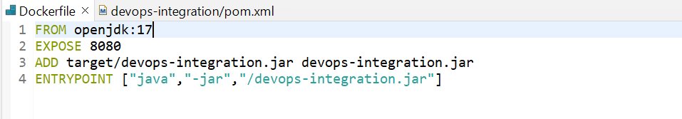

------------------------------------------------------------------------------------------------------------------------------------

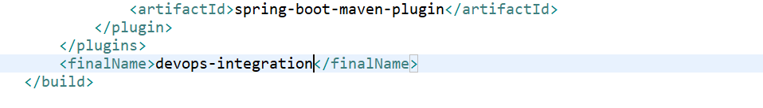

Execute cmd mvn install to build jar in target folder.

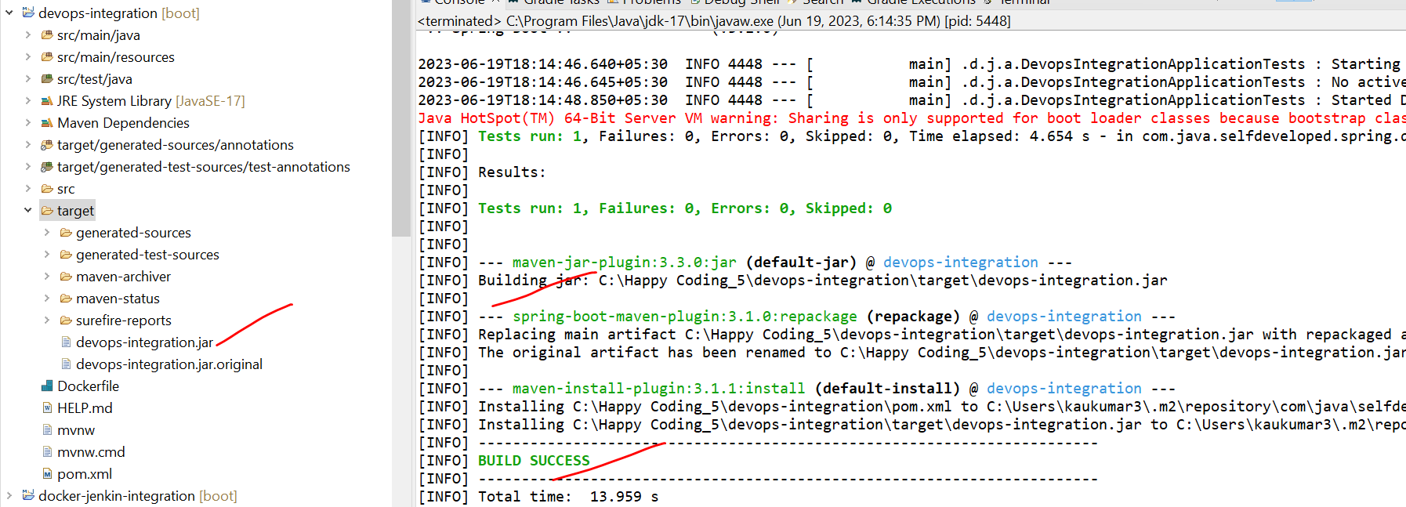

We created the docker file now we need to build the docker image

So, let’s commit these changes to git

So now in our jenkins pipeline file we need to define read my Dockerfile and create a docker image.

Before adding make sure docker desktop is up and running in your machine.

Let me add another stage to create and build the docker image. Withing stage I need to add what steps I need to perform to build docker image.so again in this step we will write and execute a script who will run and create a docker image.

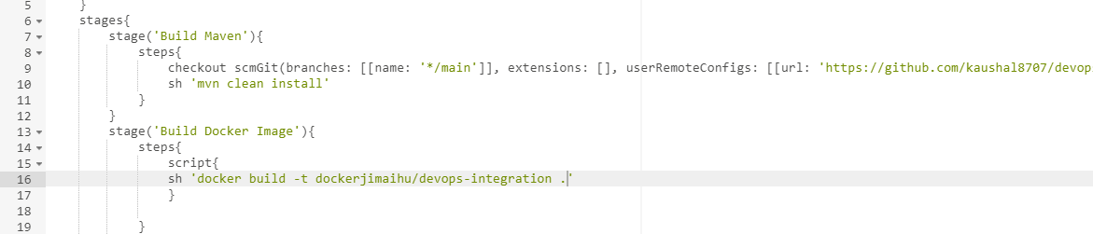

Make sure our docker desktop is running. Now save and start build.

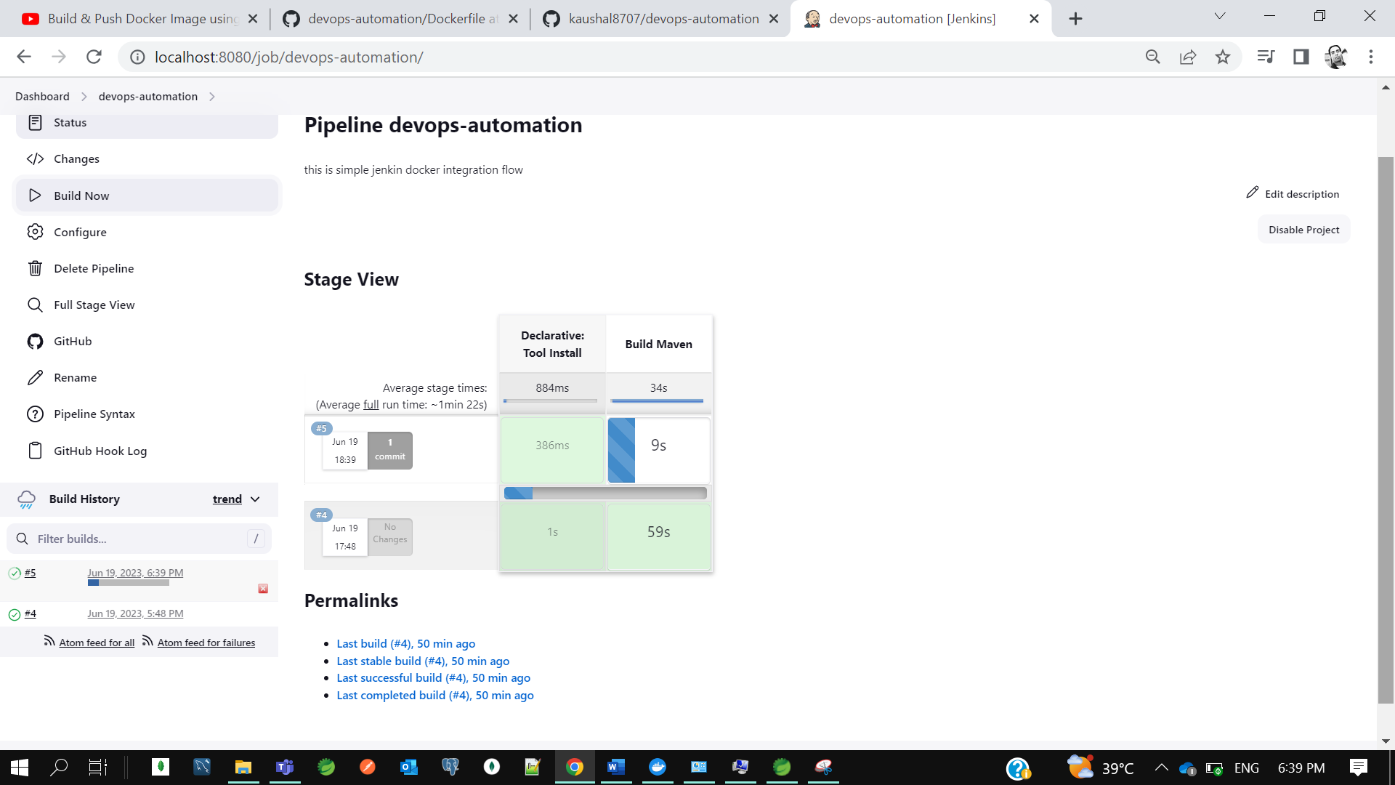

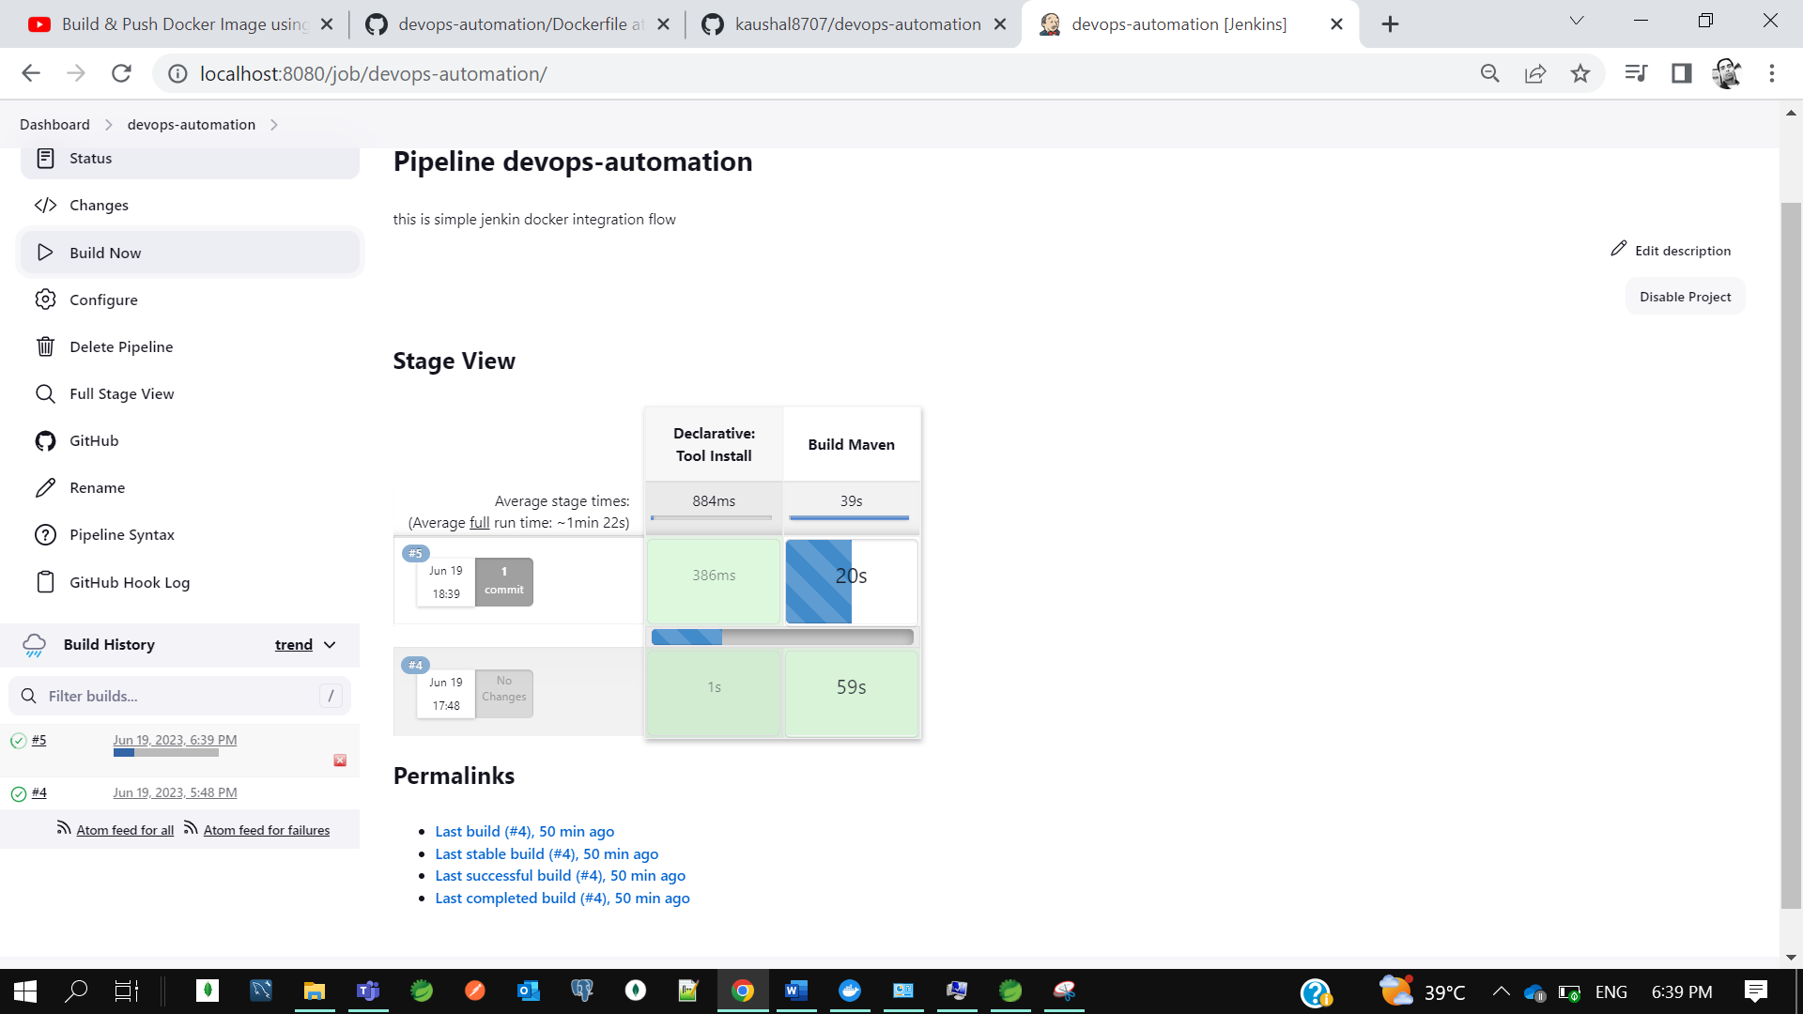

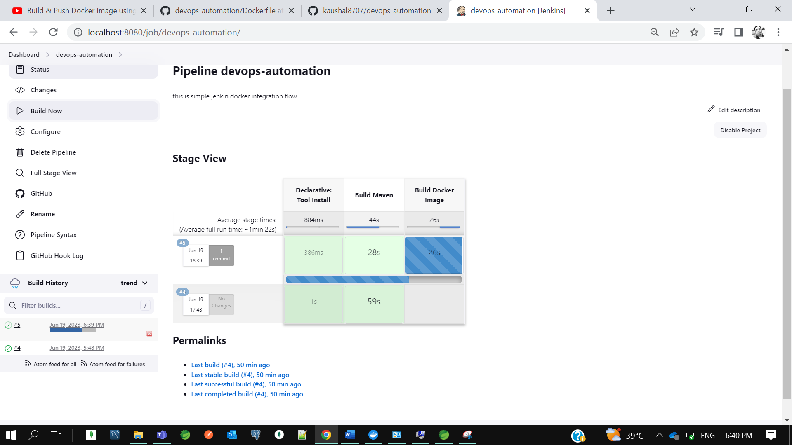

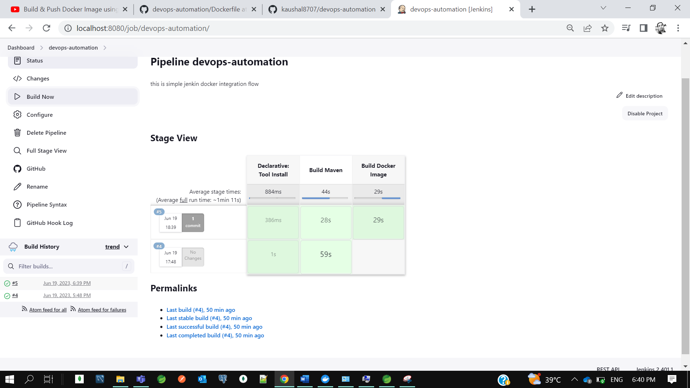

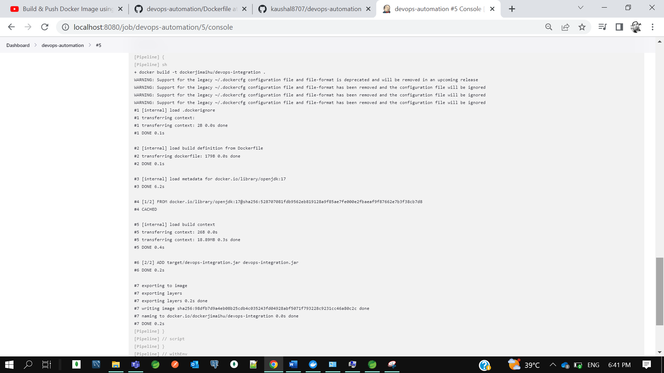

So, our build got success and image got created.

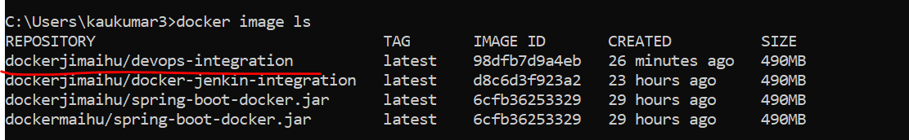

Now next step is like I need to mention in jenkins file I want to push docker image to docker hub. So again, I need to define a stage. For each step or requirement, I need to define separate stage. Now I want to push docker image to docker hub.

Now to push any image to docker hub I need to login first on docker hub.

So now click on pipeline syntax and let’s see.

Select : **withcredential**- Bind credential to variable

Now select secret text for binding.

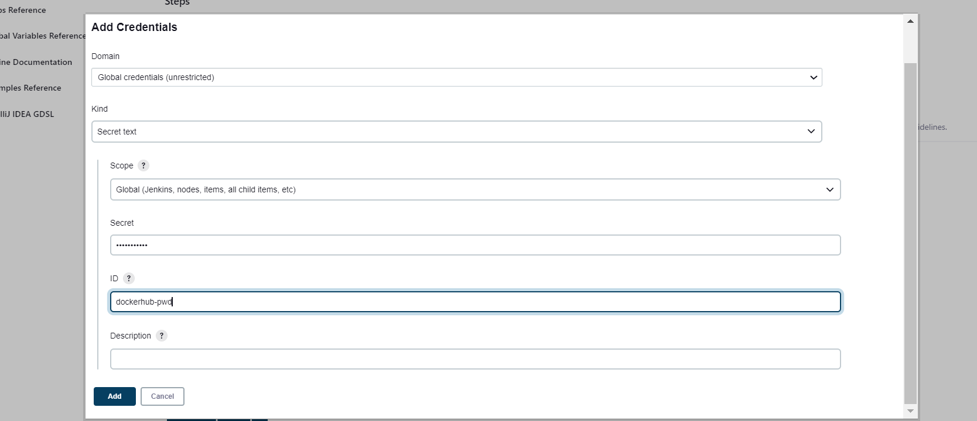

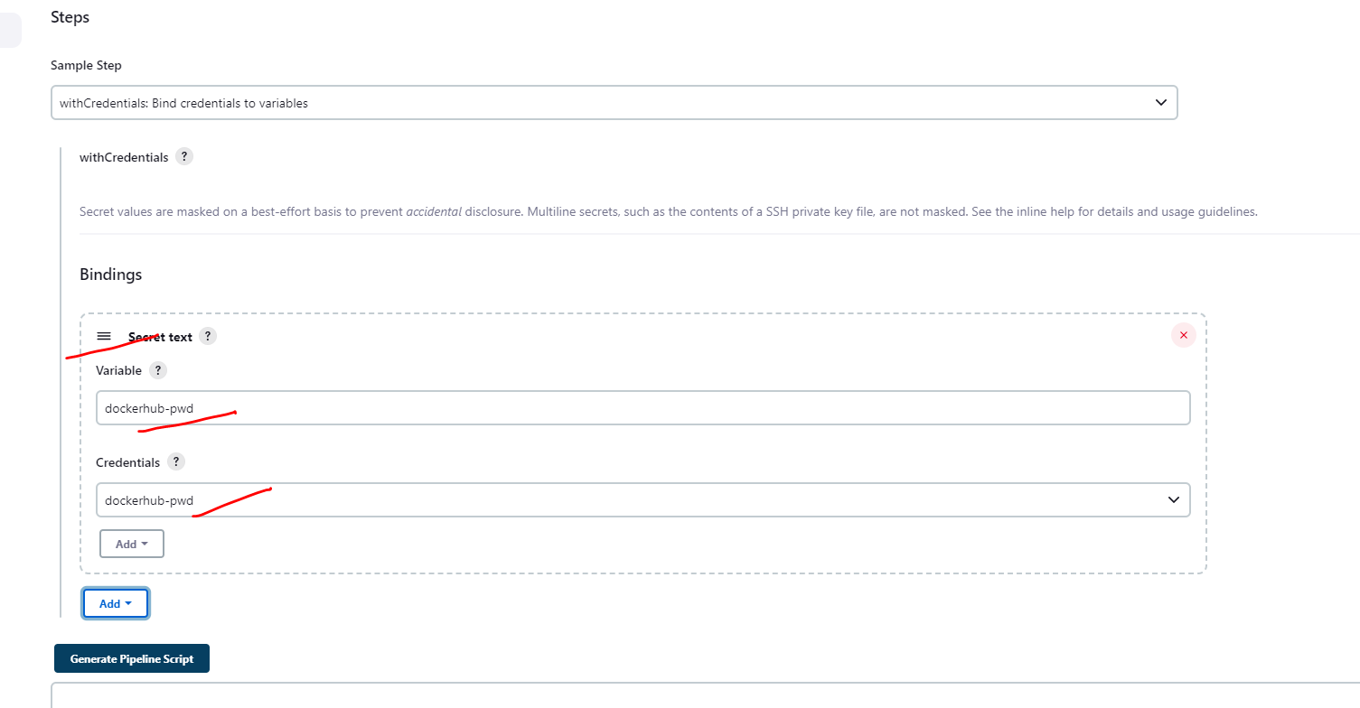

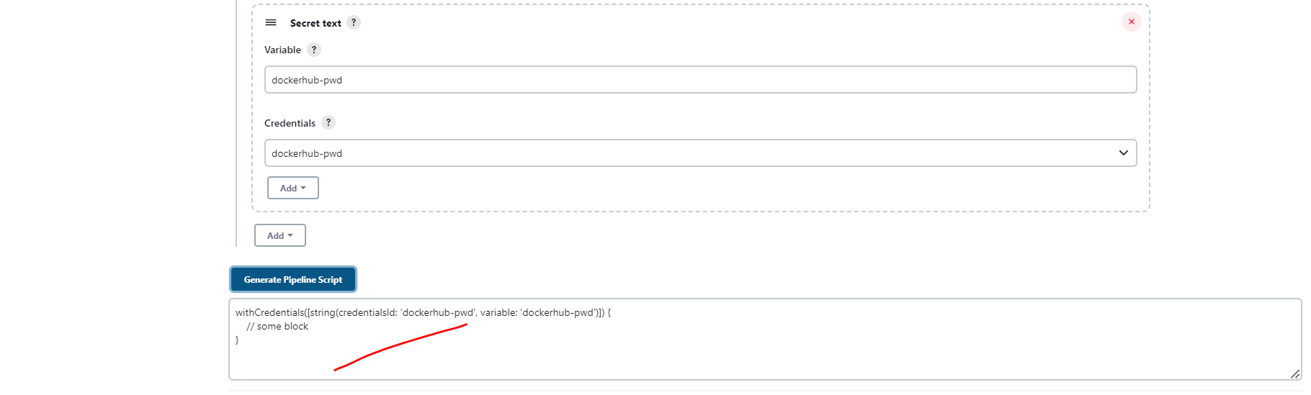

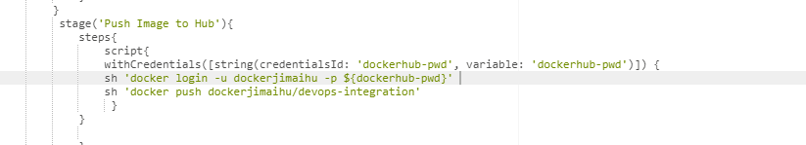

Let’s first open our docker hub.

Let’s save and start build now.

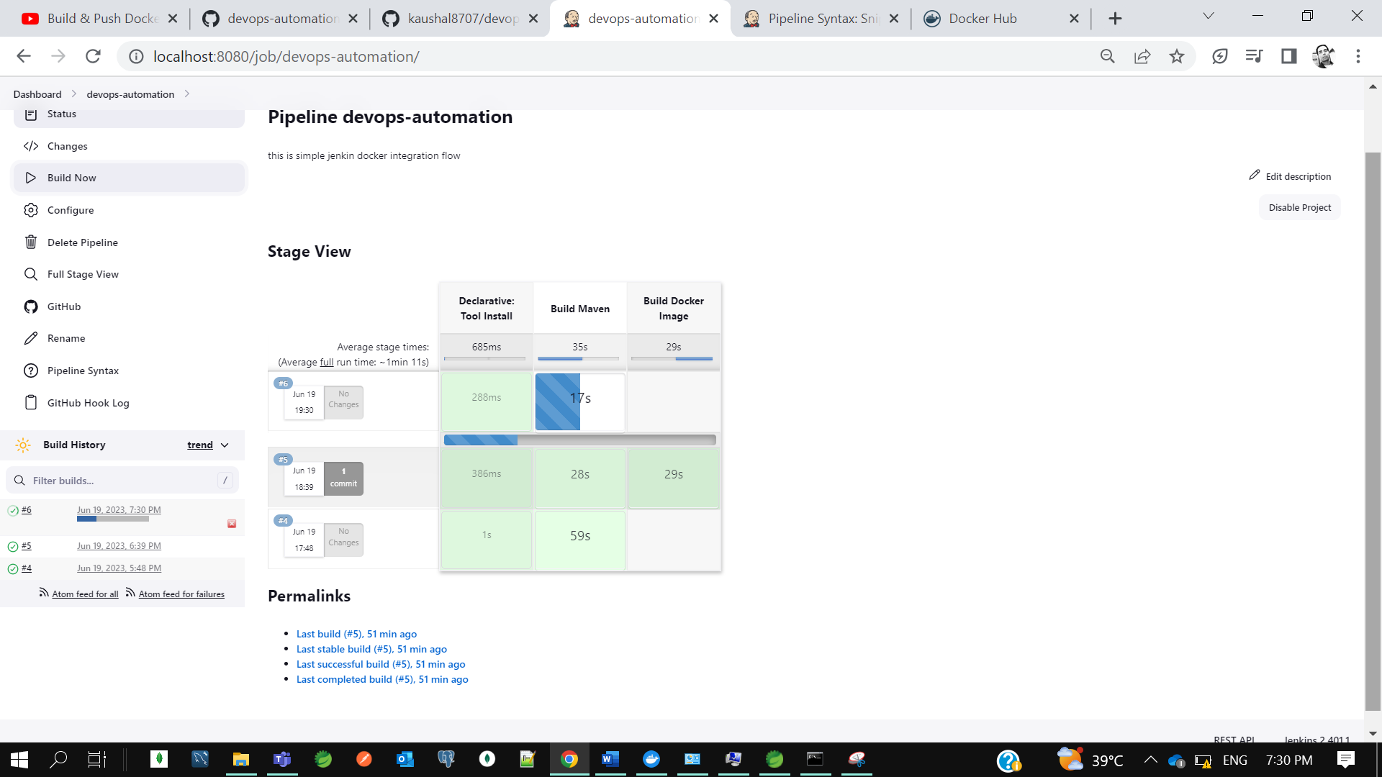

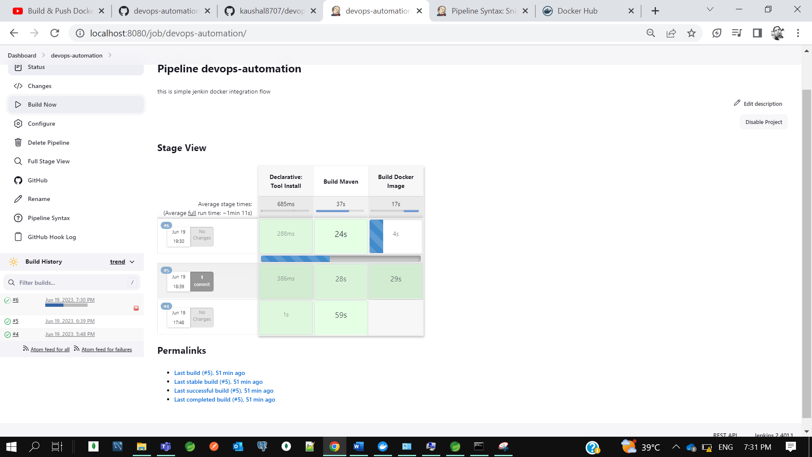

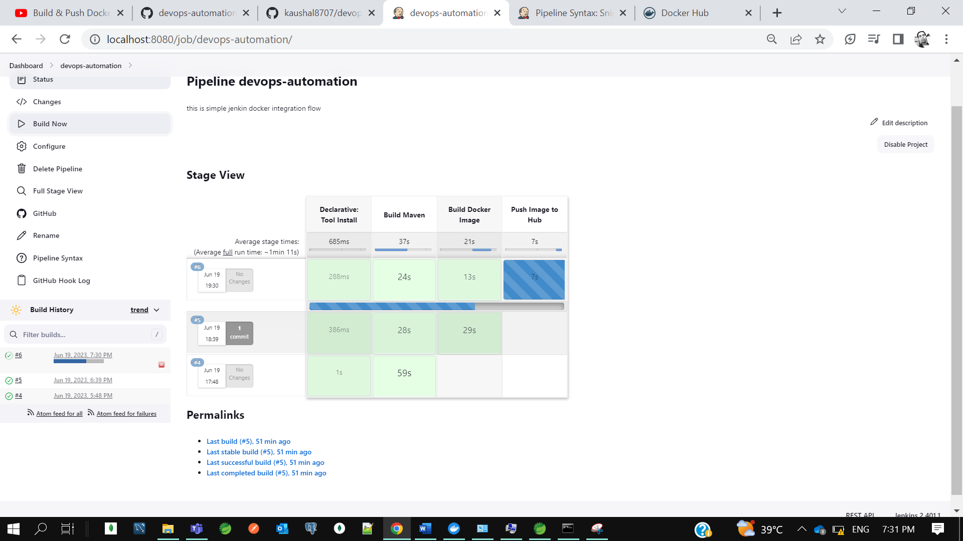

Now using the jenkins file we are able to build create image and push the image to hub. This is actually manually we created in jenkins portal itself. If I don’t want to keep global, I want to keep jenkins file in my code itself, we can do it. Let’s create in our project one file called **Jenkinsfile.**

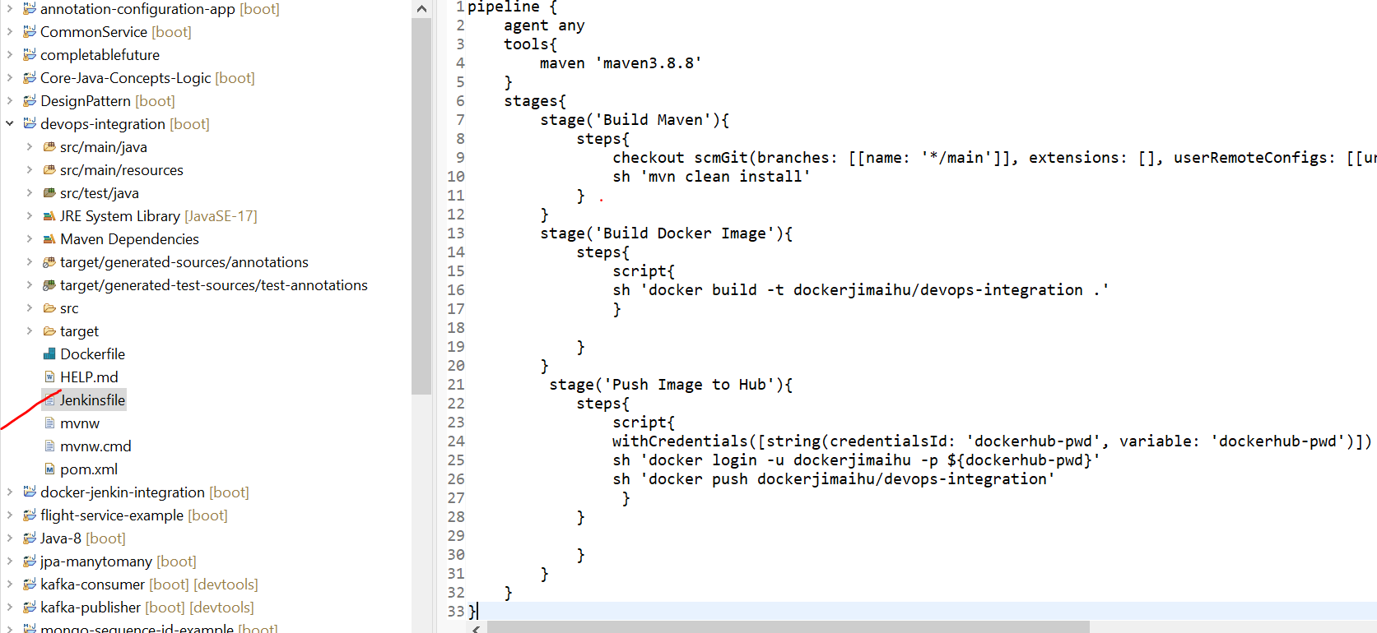

So rather than keeping in jenkins portal we can keep jenkin file in our code base itself so we can customize as per requirements.

Let’s commit our code to git.

Now let’s create another pipeline instead of changing the existing one

Now for pipeline I will load the jenkins file from application rather than writing jenkins pipeline script on jenkins.

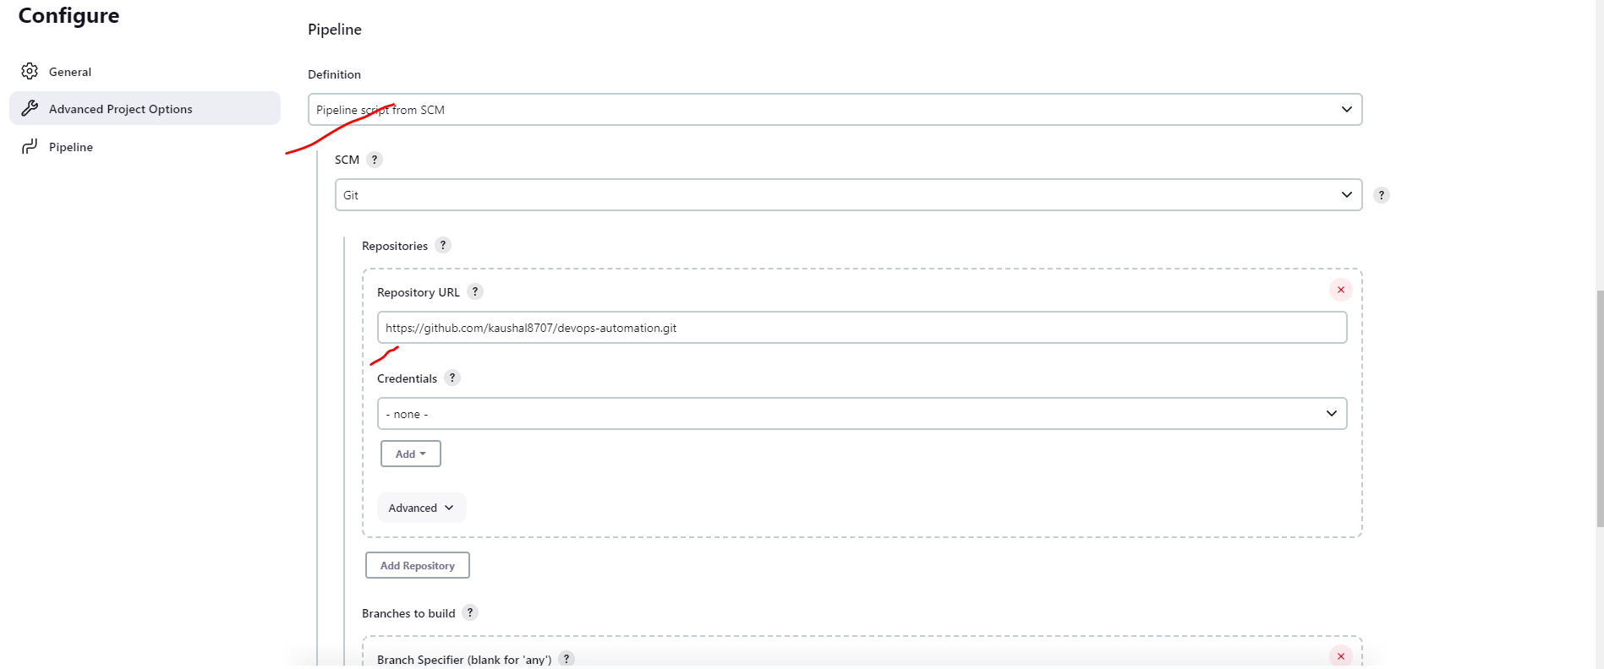

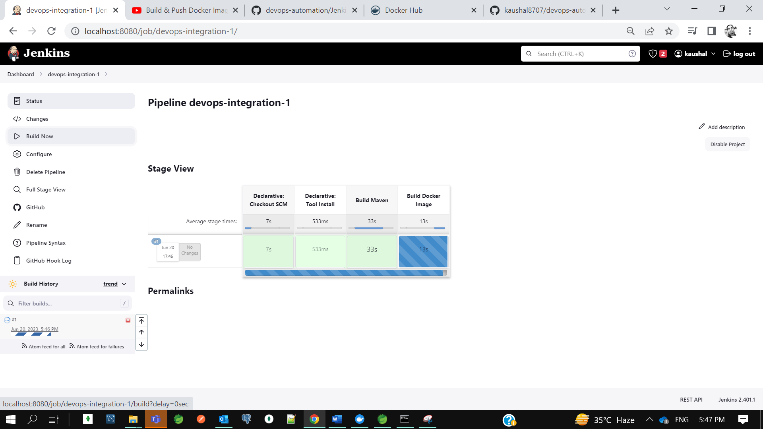

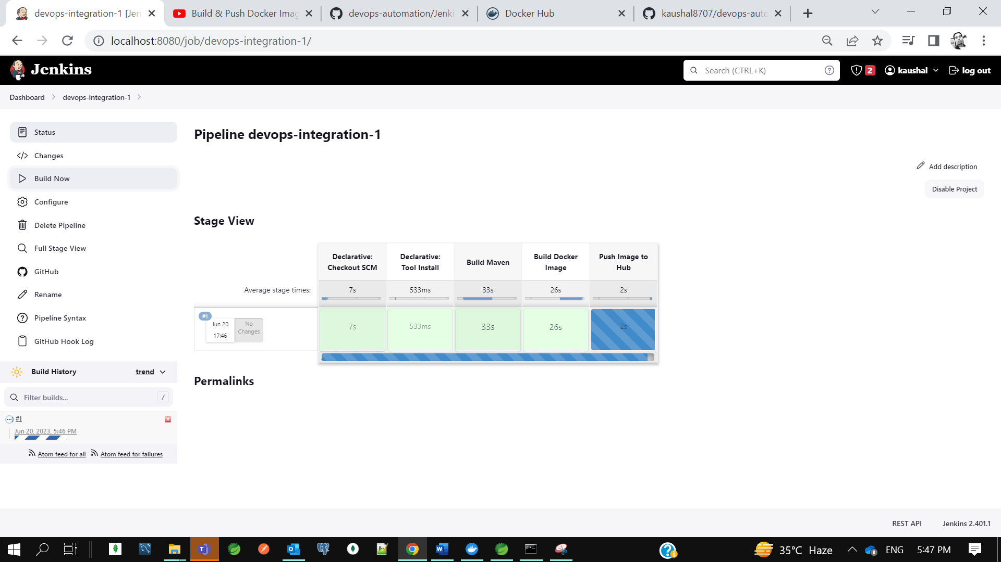

U can see on docker hub. So, this is what all about Declarative Jenkins pipeline approach. That is what the industries follows guys. No one is using the plugin and all. They usually write the jenkins file in their application and they just define stages to perform.

* **CI CD Pipeline Using Jenkins | Deploy Docker Image to Kubernetes using Jenkins**

.